The Project on Capacity Development of KUKL to
Improve Overall Water Supply Service in
Kathmandu Valley

Operation Manual
for
QField basic operation
GIS application Software for fieldwork

July 2023

JICA Project Team

Table of Contents
1. QField App 1
1.1. Installation of QField App 1
1.2. Open QField App in the TAB 2
2. Steps for preparing the Qfield Project for each Supervisor 3
3. Interact with the map¶ 13
3.1. Map legend¶ 14
3.2. Adding point features 14
4. Identify features¶ 16
4.1. Fieldwork 16
5. Miscellaneous Features in the QField Application 19
5.1. Taking the Photograph 19
5.2. Measuring tool 20
5.3. Lock Screen 20
5.4. Tracking 21
5.4.1. Activate tracking 21
5.4.2. Tracking underway¶ 22
5.4.3. Terminate tracking¶ 23
5.5. Navigation¶ 24
5.5.1. Activating navigation¶ 24
5.5.2. Disabling navigation 24
6. Email The Customer’s Location Screen Shot 25
7. Preparing the Customers House Location Map 25

INTRODUCTION

This text book has been created under the “Project on Capacity Development of KUKL to Improve Overall Water Supply Service in Kathmandu Valley” through the technical cooperation funded by JICA (Japan International Cooperation Agency) to the KUKL.

This document was written in the collaboration of JICA project experts from Japan side, and assigned project officers from KUKL side. The main objective of the document is to study the fundamentals of GIS, and to increase the numbers / skill of beginner GIS operators.

The document has been created to be used in a GIS basic level training course organized by a trained expert GIS officer. The training course guideline and curriculum shall be referred to make this document most effective and efficient use.

The document is not allowed to be copied / modified without the approval from KUKL or relevant officer.

QField App
QField leverages the power of QGIS to comfortably configure your projects. After setting up everything, you can then synchronies your project and any additional files to your device and immediately get down to work.
Synchronizing your projects to your teams' devices, can be done in various way. The QFieldSync plugin helps preparing and packaging QGIS projects for QField and distributing it to your devices. For a seamless integration experience and for managing teams we highly suggest using QFieldCloud.
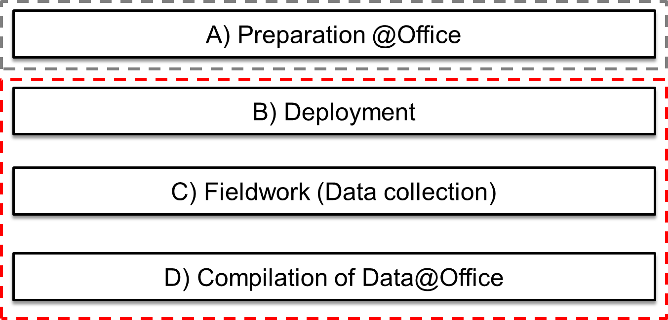
Figure: Basic Workflow

Installation of QField App
QField can be used with any version newer than Android 5. Go to the Google Play Store App and search “QField for QGIS” and Install it.

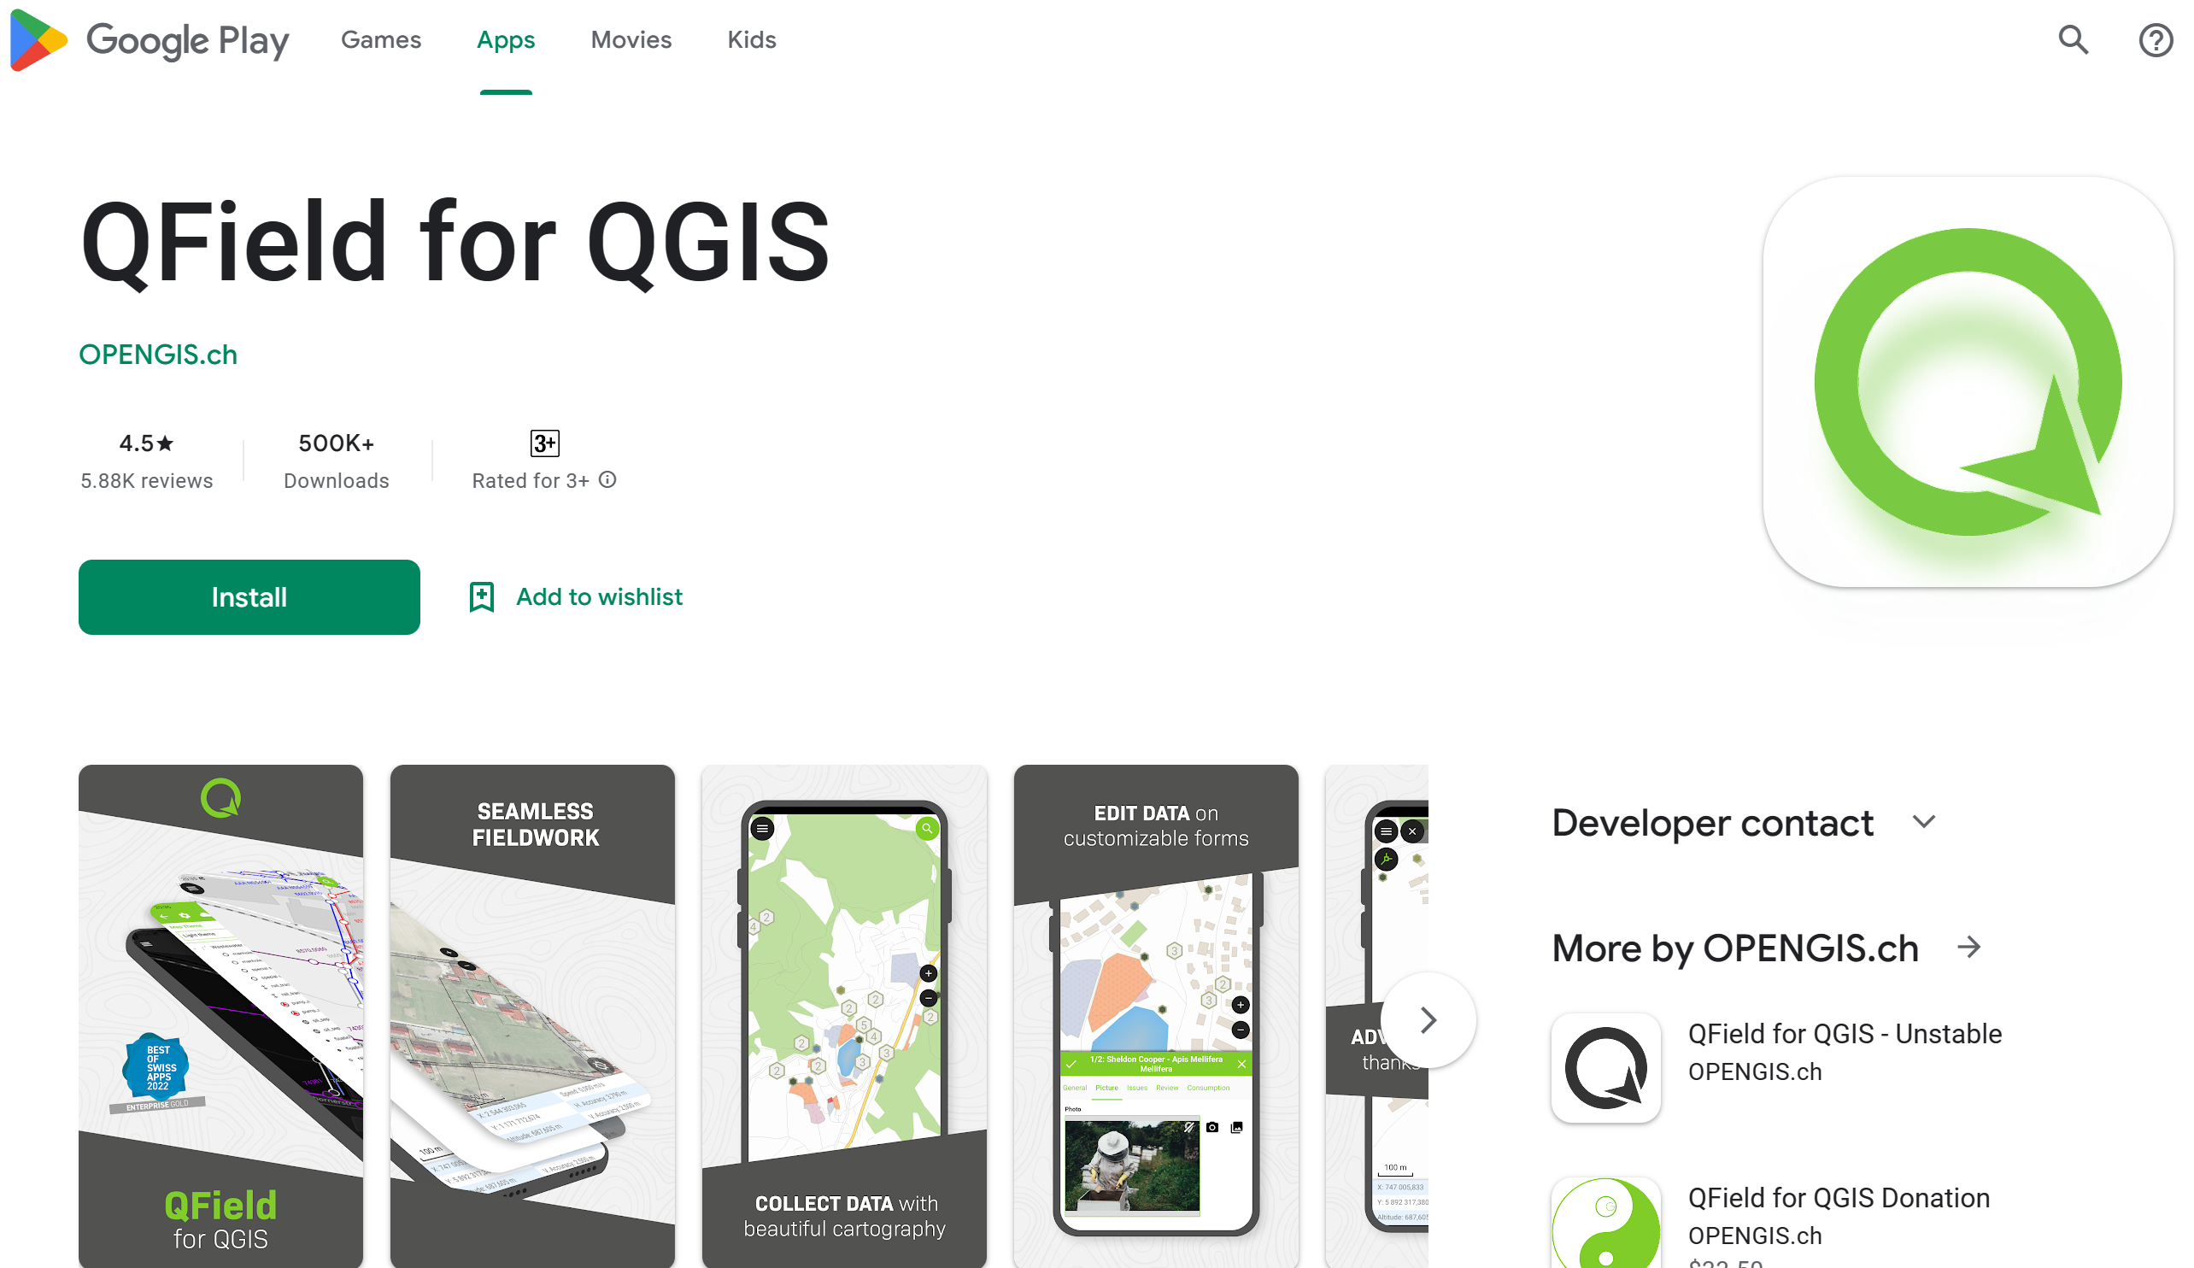
Figure 1: QField for QGIS in Google Play Store for Tab

Open QField App in the TAB
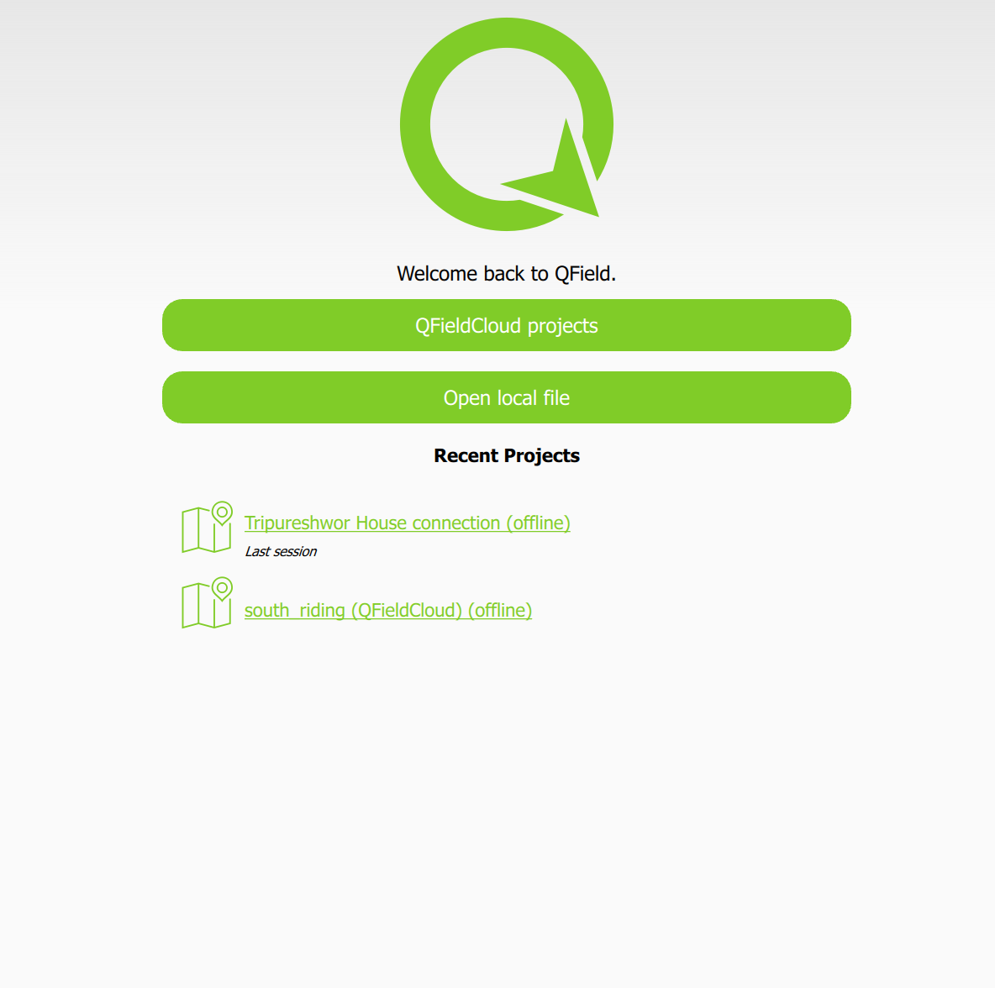
Figure 2: QField App Opening Window
QField https://www.qfield.org/
- Android app of QGIS especially aimed for data collection at field work
- Android Version 1.9.6 or above
- Download and install QField through GooglePlay
https://play.google.com/store/apps/details?id=ch.opengis.qfield

Steps for preparing the Qfield Project for each Supervisor
- Label the Kathmandu_valley_ward layer inside the ward_boundary.gpkg with Nagarpalika_name and ward number
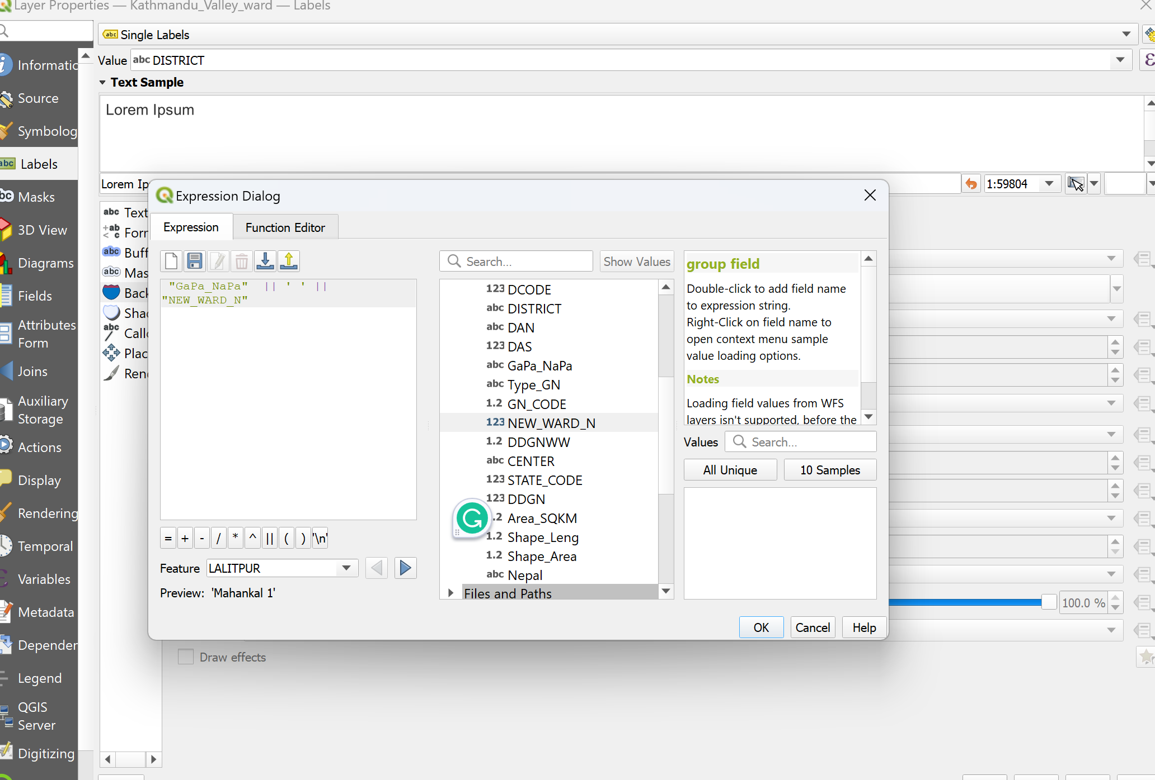
- Select the area (wards) from the Kathmandu_valley_ward layer inside the ward_boundary.gpkg using the select tool
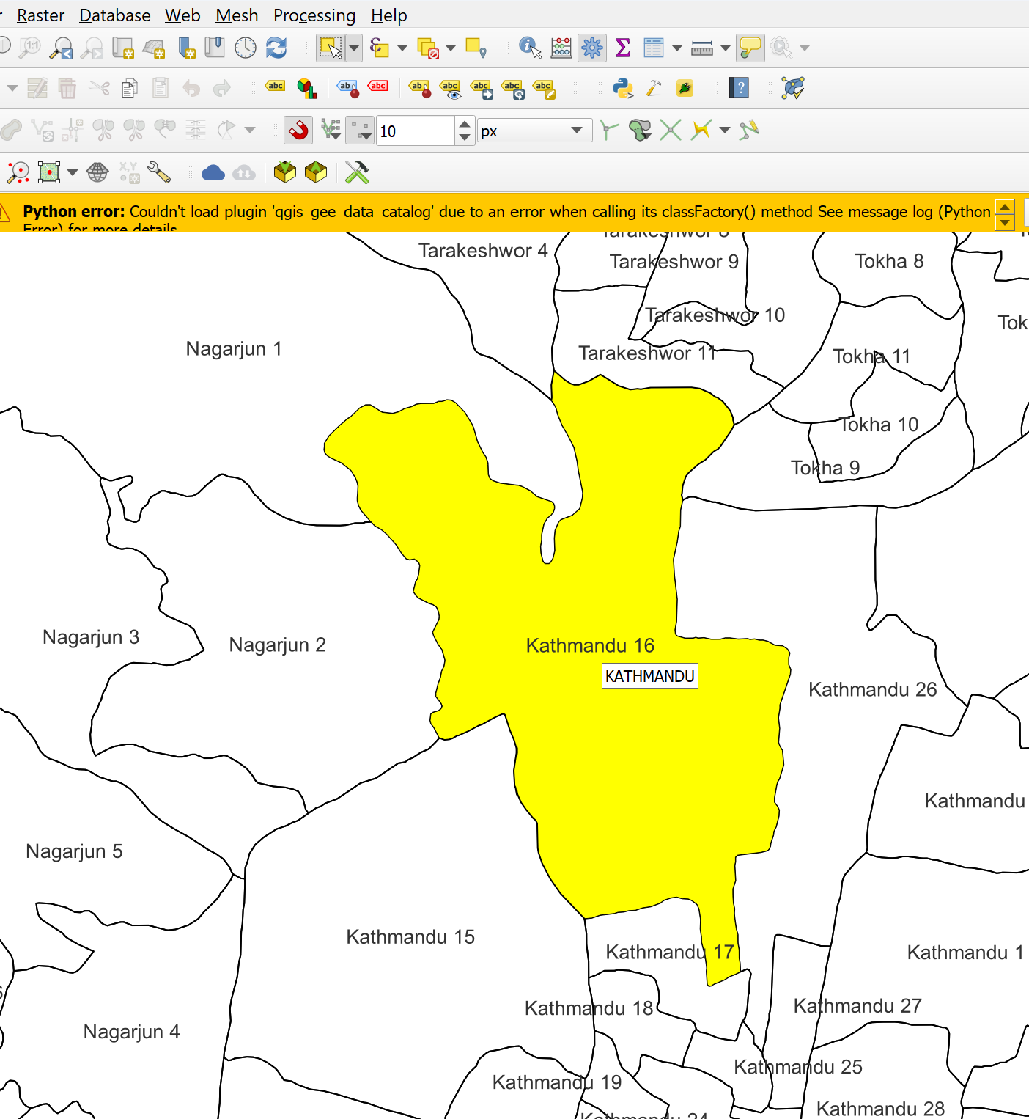

- Create a Buffer of 100m for the selected Area using Menu->Vector->Geoprocessing->Buffer. Save this as a temporary layer

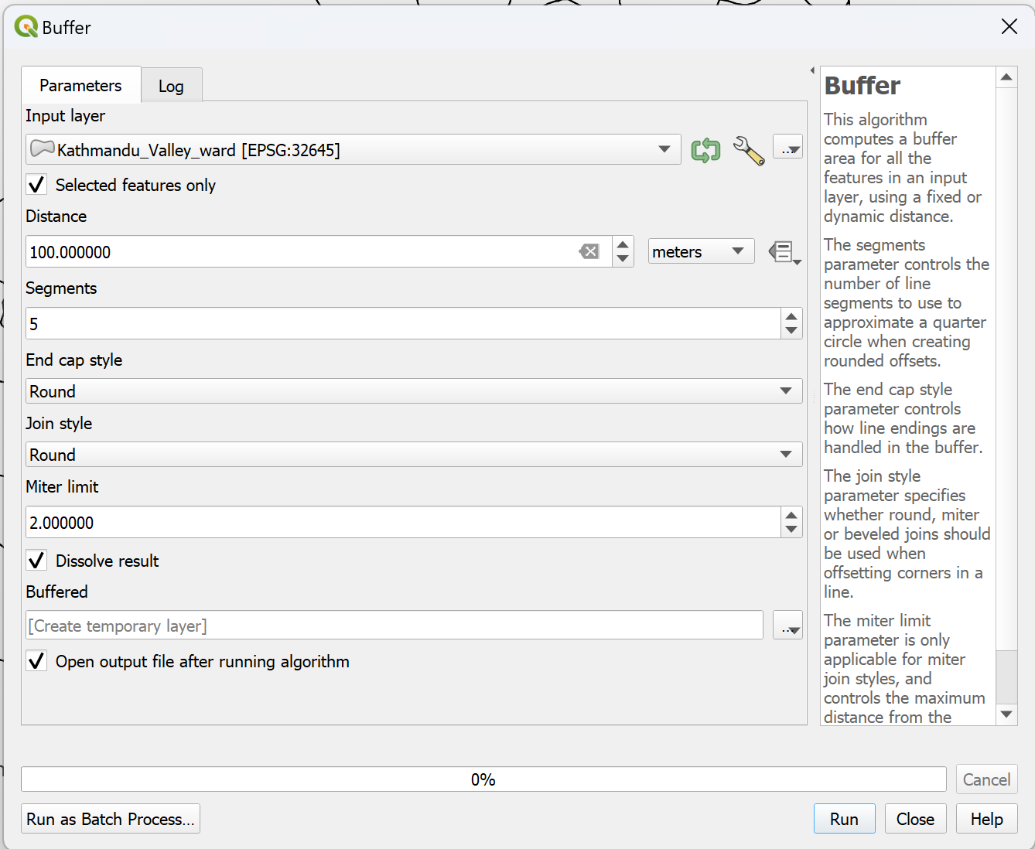

- After Buffer the polygon will be used as the boundary of the map.

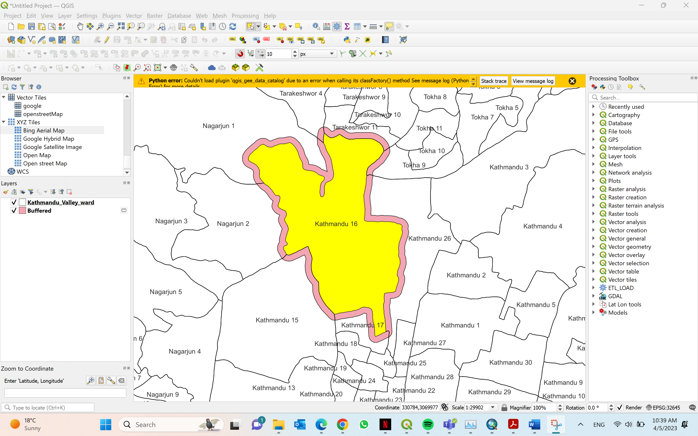

- Download the Open Street Map of the Area using QuickOSM plugin (if this plugin is not installed, please install one time). If the OSM data is not available.
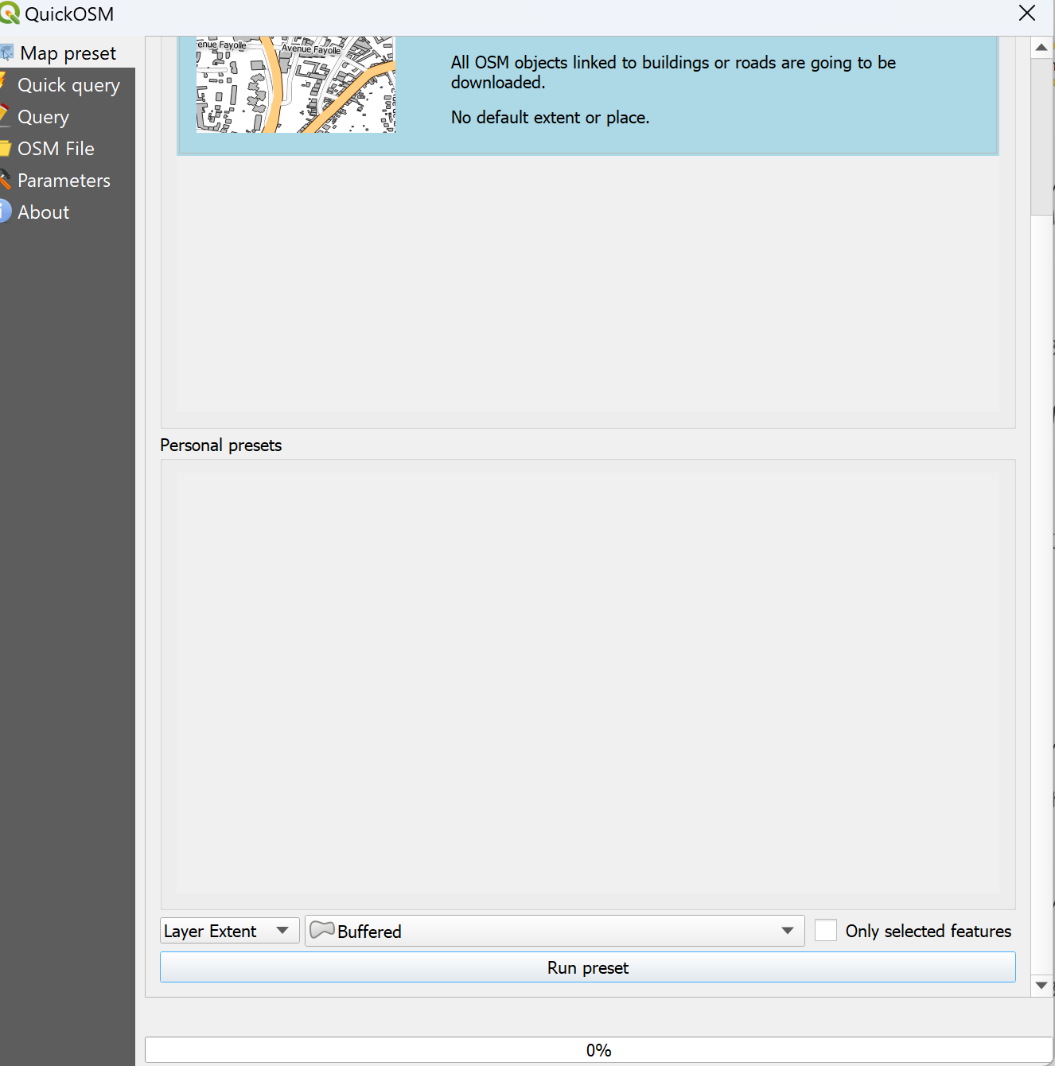
- Download the layers of Buildings and Road
- Create the spatial index for both layers using the Processing tool and search ‘create spatial index’. After creating the spatial index delete all the fields from buildings except the building name to reduce the size of the file.
- Similarly delete all the fields from the Road layer expect
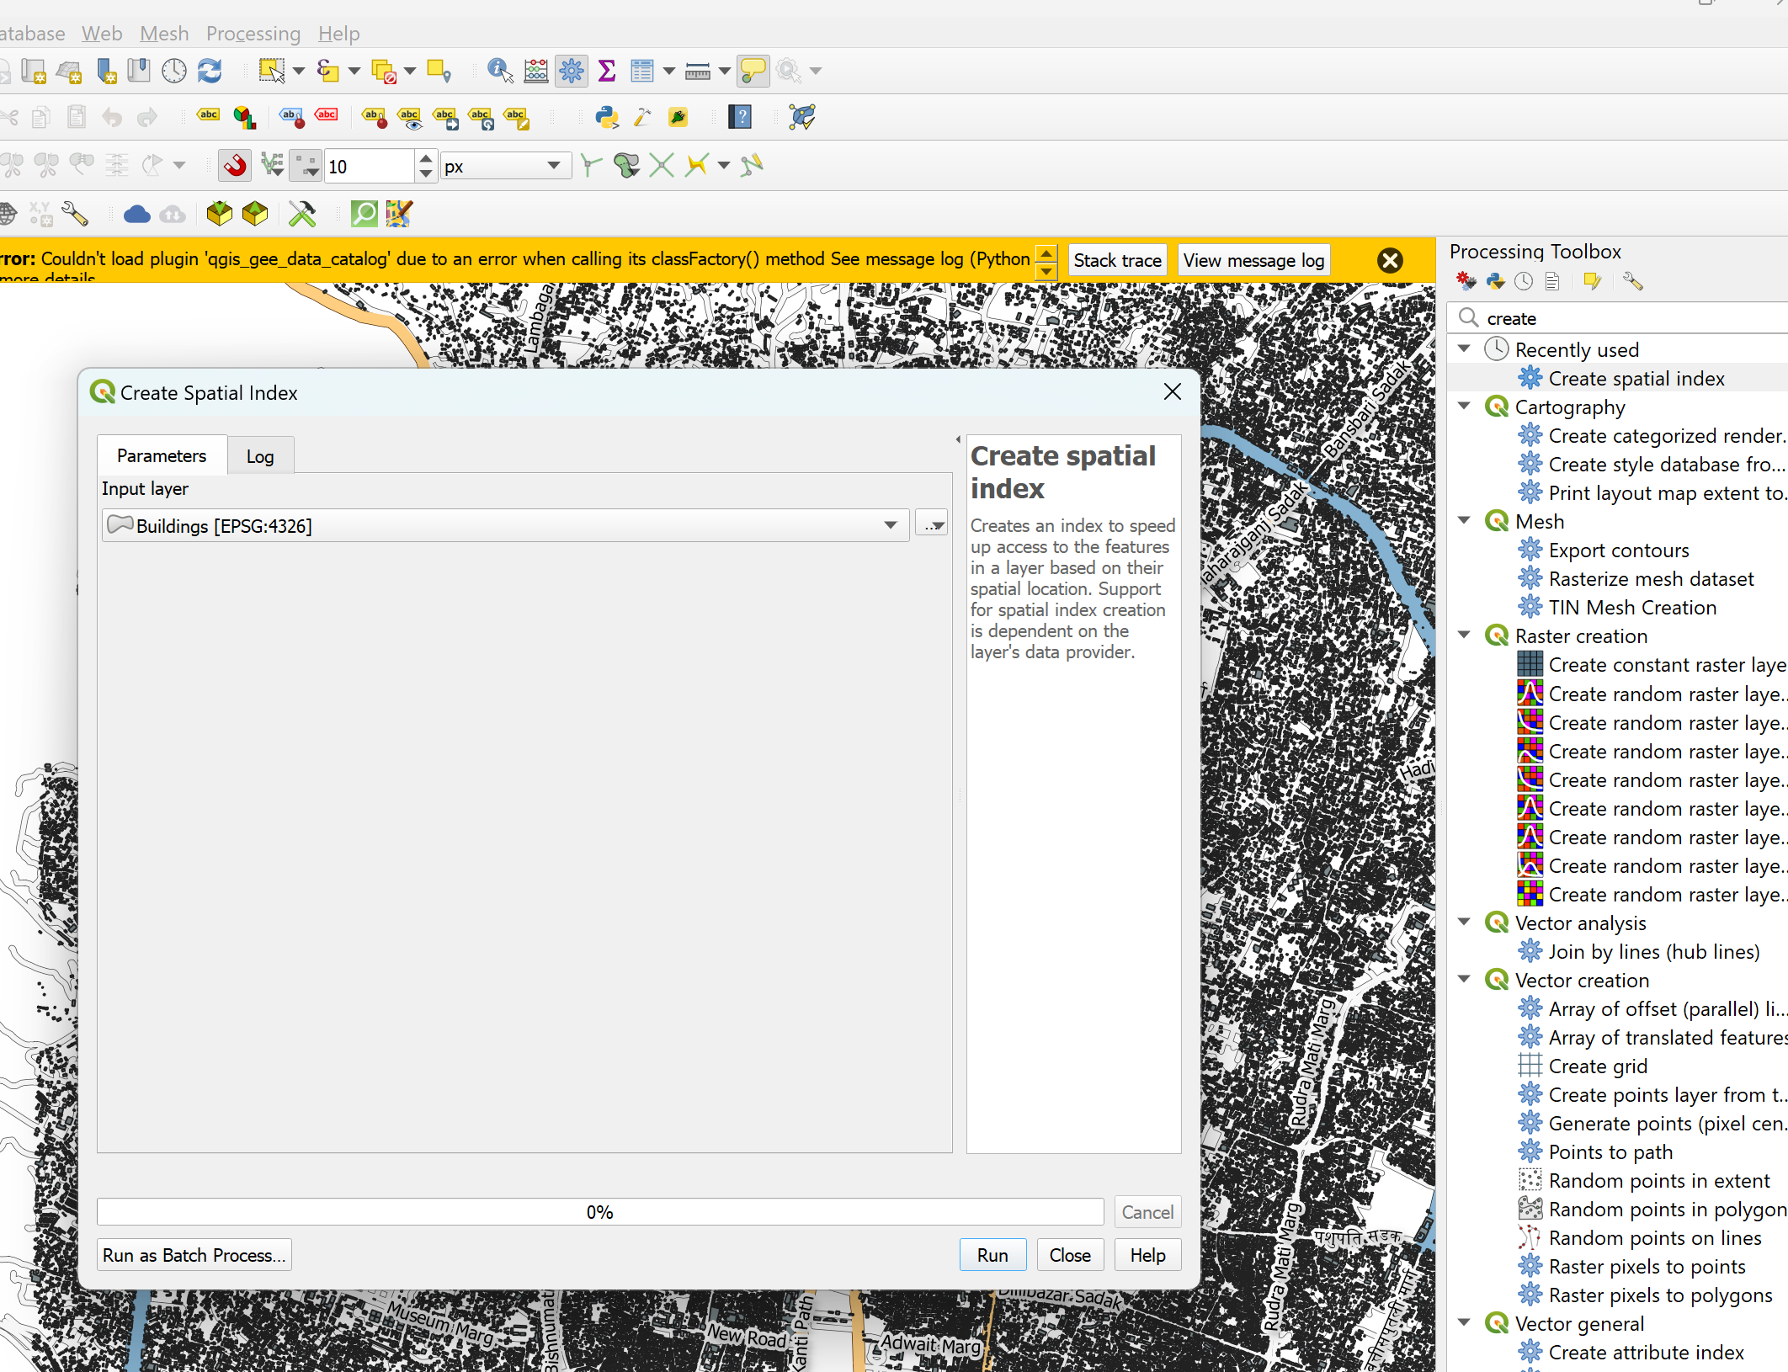

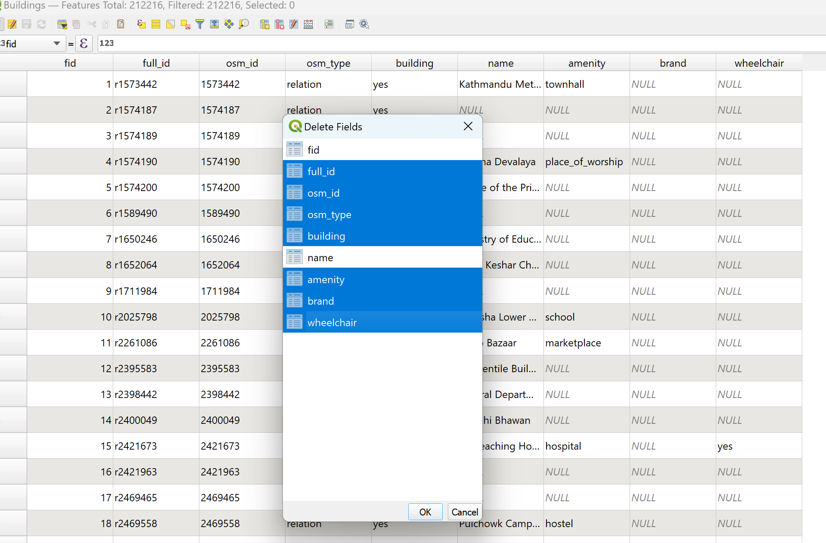

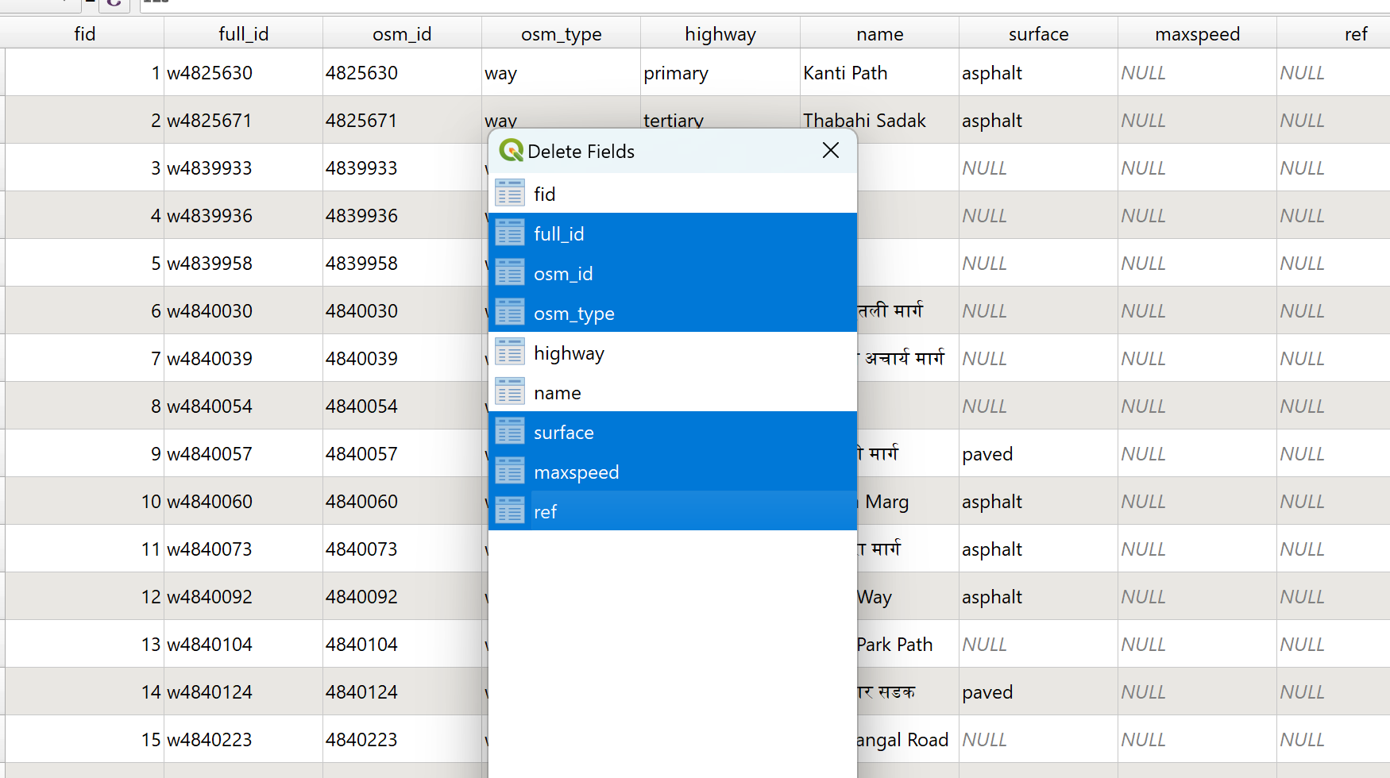
- Add Buildings and Roads from Pre-downloaded OSM if it is available with you.
- Clip (Menu-> vector-> Geoprocessing->clip) the buildings and roads layers with buffer_Area layer and saved in supervisors_name_OSM.GPKG (a new Geopackage)

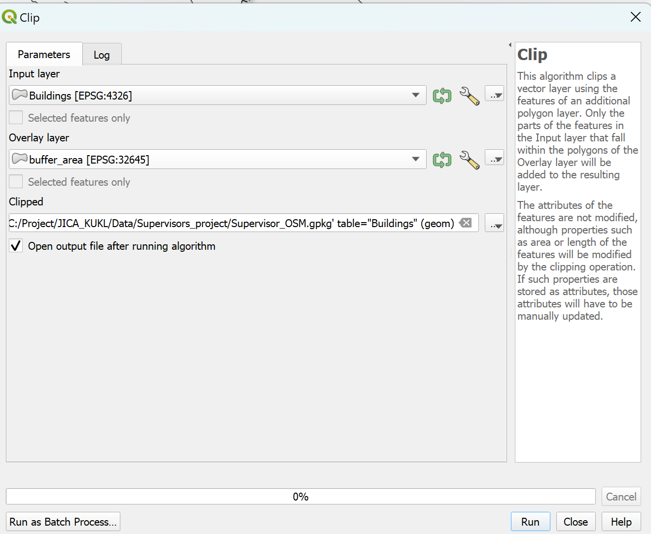
- From KUKL_all_ExistingNetwork.gpkg (inside the training folder) export pipes in a different Geopackage (Master_pipes.gpkg). Delete all fields except Dai_Nor and Mat_Type (to reduce the size of the database)
- Clip the pipes from Master_pipes.gpkg with Buffer_Area and save it in supervisors_name_OSM.gpkg as pipe layer
- Copy the Supervisor_name_OSM.gpkg) to the existing supervisor directory. Also copy three qml files (Road.qml, Buildings.qml and pipes.qml) to the same directory if it is saved at a different location. Make sure Qfield_data.gpkg and Qfield_Project .qgz are in the same directory. If not, copy these two files (imbedded in this document) to the supervisor’s directory.
- Open qfield_project.qgz and add Buildings, roads and pipes layers from supervisors_name_OSM.gpkg Apply the corresponding style files to the layer and create a supervisor project.
- 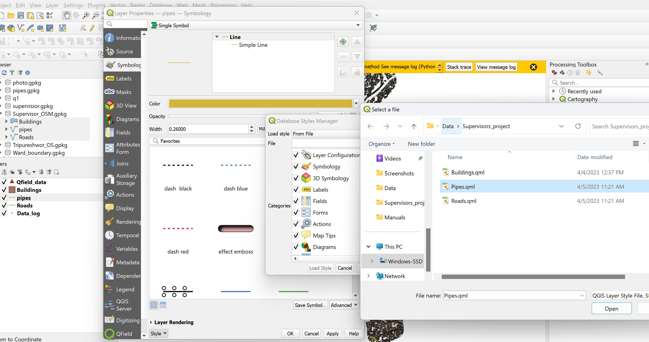

- Open the Qfield_data layer property. Then go to ‘Attribute_form’ and check all attributes. Attribute ‘Data_collection_date, Lat, Long and set it to default data acquisition. Make a change to the ‘Field data collector’ default value to the Supervisor’s name.
- 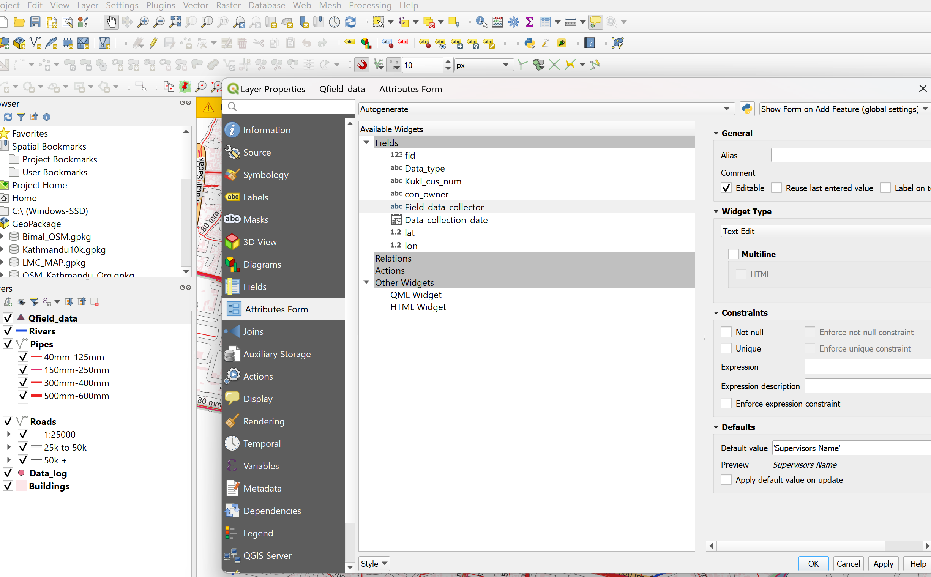

- Each supervisor should have a separate project for his service area. This project will be smaller in size and easily handled in the supervisor’s mobile.

- Create Export and Import directories in the supervisor directory.

- Use 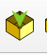 tool in QfileSync plugin to create the Qfield Project and save in Export directory

- Copy the Export directory to the supervisors mobile in /Android/data/ch.opengis.qfield/files/imported Project

- Collect the house and hole locations in the field. Every two weeks the collected data should to transferred to the master computer. Connect the mobile to the master computer and copy all the contents of the /Android/data/ch.opengis.qfield/files/imported Project directory in the import folder of the supervisor’s directory. Open the supervisors project and use 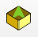 to synchronize the project. Once the project is synchronized you can see all the collected field data in the Qfield_data.gpkg.
- Edit the KUKL_cus_no field, if it is not updated. Review the downloaded data and edit if anything is missing. Select all “Hole Location’ records as shown in Figure.
- Our Master dataset (PID DNI datasets) are in WGS84-45zone, however our Qfield_data is in WGS84, so we have to project Qfield data in WGS84-45zone, which can be done by right click the Qfield_data -> Export -> save features as -> and set the CRS as WGS84-45Zone and Geopackage name as in every two weeks save in the supervisor’s directory. Keep this as backup GPKG.
Qfield_data_supervisorName_date.gpkg 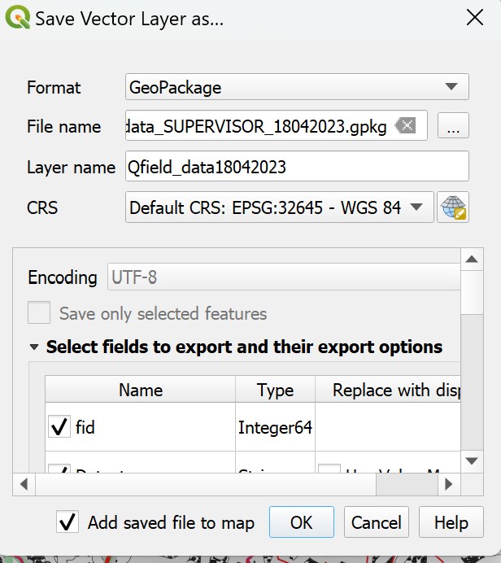
- Install the plugin ‘Append Features to Layer’ from the Plugin Menu. (First time only). Open the ‘Processing Tool Bar’ and search ‘Append Features to Layer’ and open it and fill as shown in the Figure
- Select all “Hole Location’ records from Qfield_data_supervisorName_date.gpkg as shown in Figure. Make sure that this selection should be done after the projection.

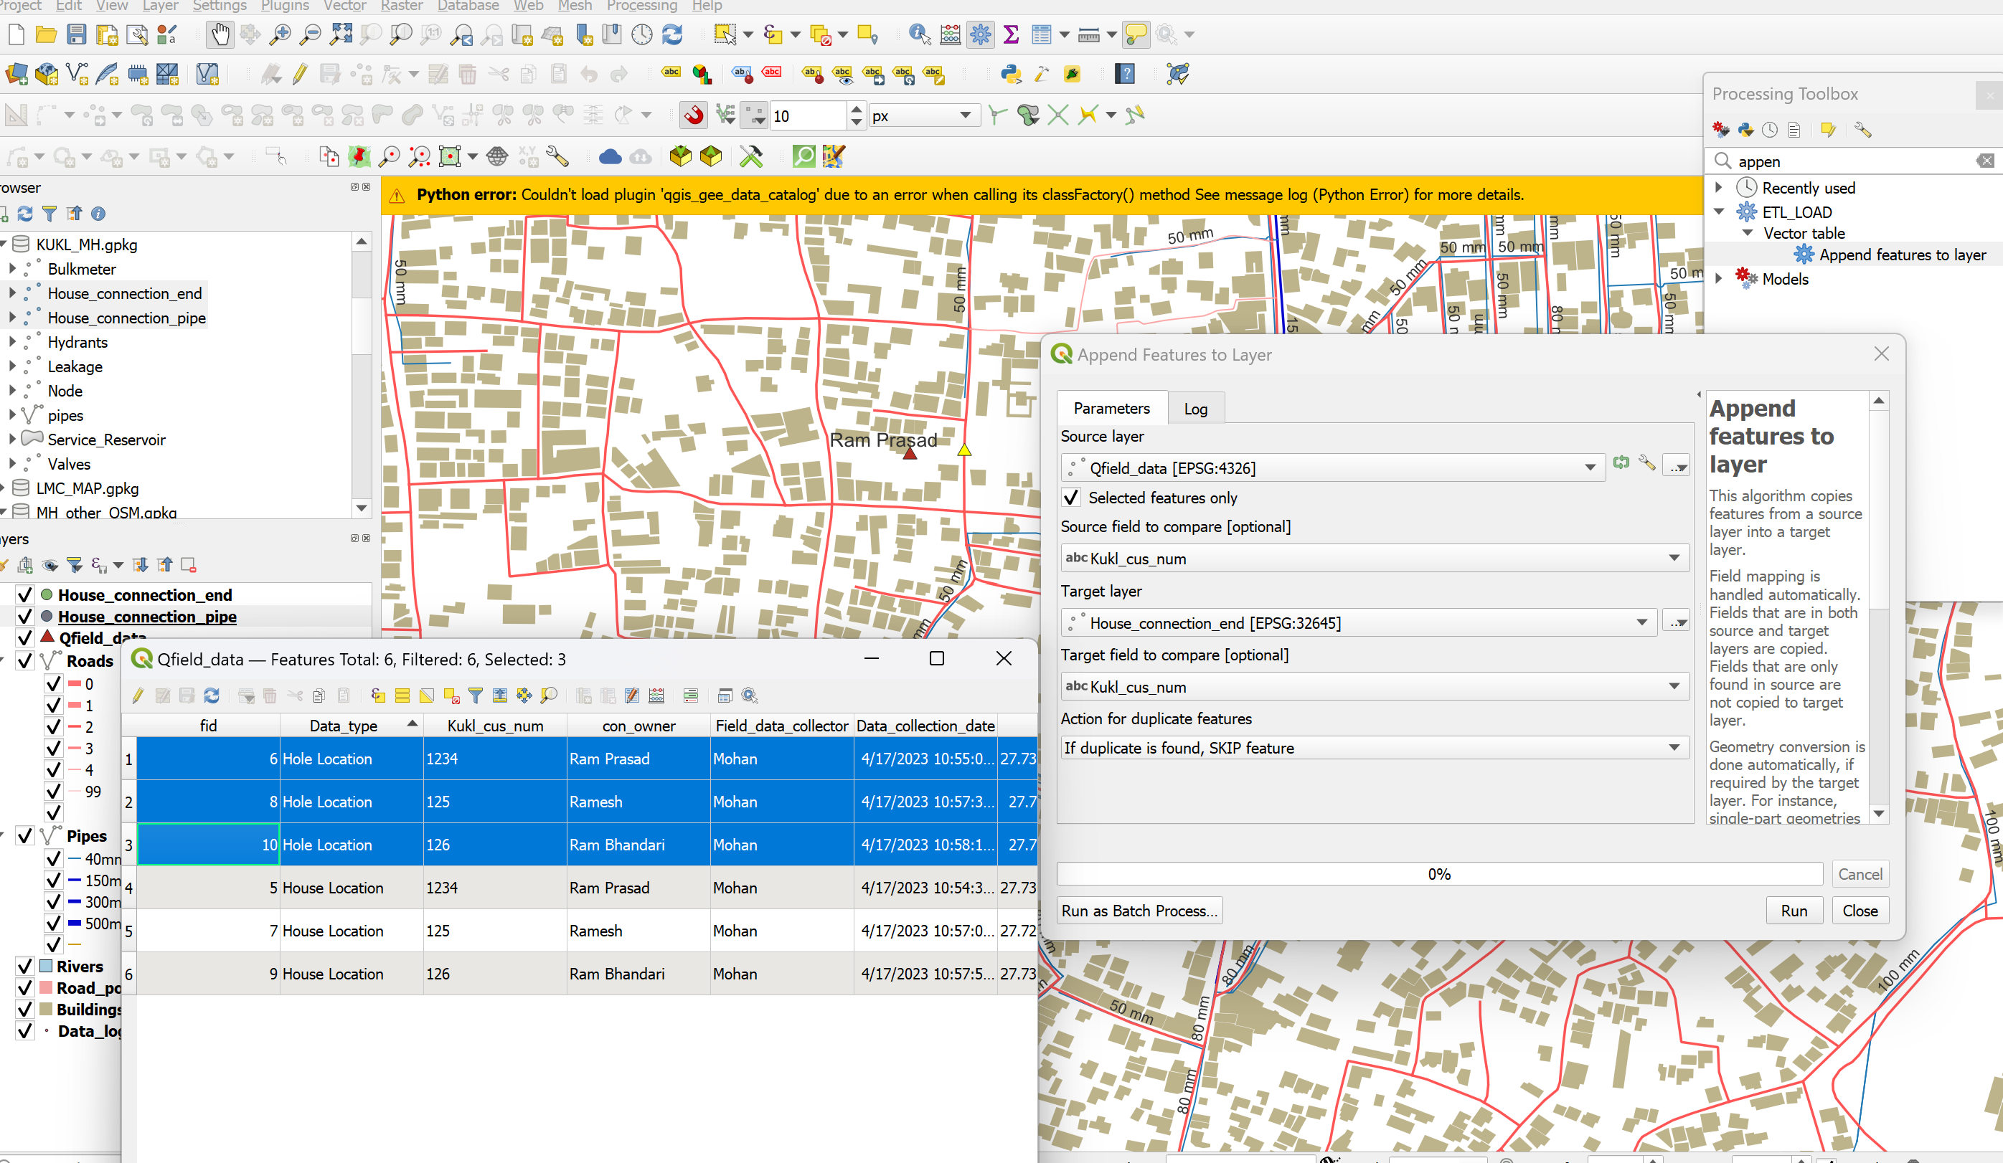

- Append selected Hole Location features in House_connection_pipe (the master database) in KUKL_MH.gpkg. Compare the KUKL_con_num attributes so that the duplicate records should not be appended to the Master dataset.
- Similarly select the House location features in Qfield_data and append them to the House_connection_end layer.
- Make the backup of KUKL_MH.gpkg periodically.

Table: Folder/File Data Management Format
S. No. | Folder/ File | Sub-folder | Description
1 | QField_Project  (Type: Folder) | Export | Only changed when new data, pipeline network is updated
 |  | Import | Copy from the supervisors’ tab data  The field data will be transferred to the QField_data.gpkg  Delete all the files in Import.  Copy the second supervisor data.  Synchronize.  The second supervisor’s data will be appended in QField_data.gpkg  Similarly continue with other supervisors
2 | QField_data.gpkg  (Type: File) | - | Data (House connection End and House Connection Pipe) should be appended to the Master Database periodically.  Keep a backup of QField_data and Master database KUKL_BN.gpkg periodically.
3 | KUKL_BN_20230720.gpkg  (Type: File) | - | Backup file
4 | KUKL_BN.gpkg  (Type: File) | - | Working

Interact with the map¶
Click on “Open Local File”. You will see a set of new folders named "QField files directory", "Imported datasets", and "Imported projects" as well as a drop-down menu accessible via a bottom-right plus button.
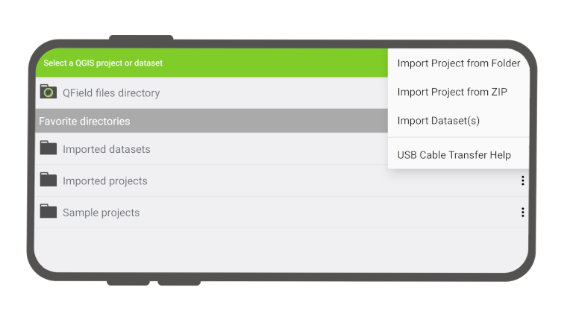
Figure 3: QField File Selector from the Local Directories
Open Local Files: Navigate to your Project which is in the (/Android/data/ ch.opengis.QField/files/) imported Project directory. Open QField_Project (Qfield project is copied in this directory). The project will load and you can see the as Figure 4.
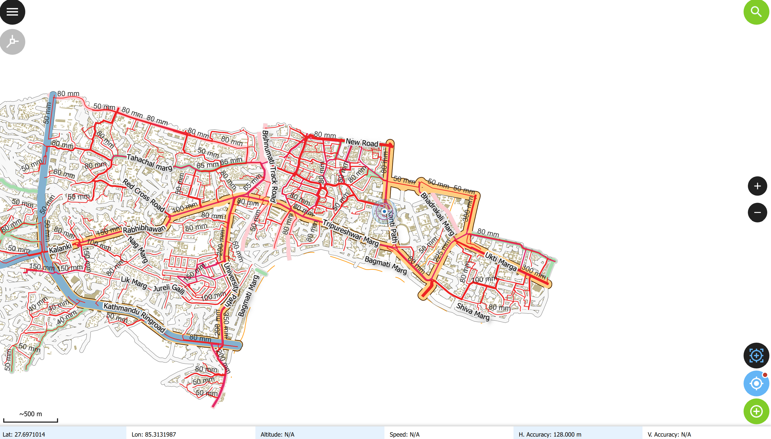
Adding Features in Edit Mode
Menu Button
Coordinate Cursor Locked and unlocked
GPS
Zoom In/Out
Topological Edition
Figure 4: Tripureshwor Service Area of the QField Project

Here are described some of the possible interaction with the map possible in QField.

Map legend¶
Open the Main menu and expand the layers list to display the legend of the map. On double-tap or long-press on a layer you get offered the following possibilities.
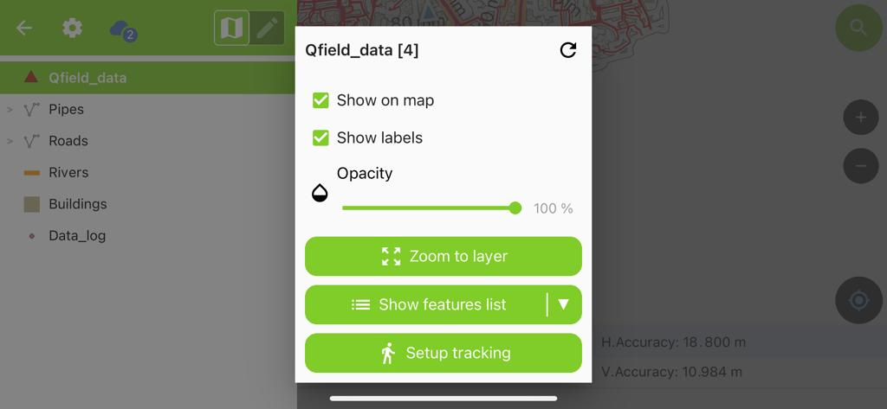
Figure 5: Features Properties (after long press on the layer in TOC)
- Show on map to control visibility.
- Show labels to control the visibility of the labels.
- Expand legend item to show/hide the layer's sub-items.
- Zoom to layer to have all the layer items on the map.
- Reload data to get the current data of a layer with remote sources.
- Show feature list to show all the layer's features in the identification list.

Adding point features

Click the left side top menu (three lines). Select the QField_data and then click at top right . You will get a message “You are now in digitize mode on Layer QField_data”.
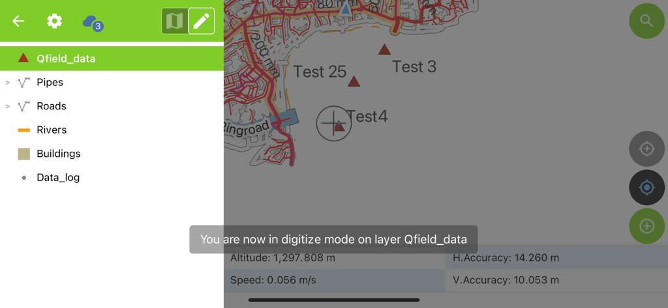
Figure 6: Edit mode of Layer QField_data
You can add point features such as house location, hole location, changed hole location, and leakage location. You can view the GPS position and approximate present location. By pressing the GPS button, the GPS location will be centered on the map. If you click the 'coordinate cursor locked' button, the digitize cursor will be locked to the GPS position (Figure 5). This is useful when you want to add a point feature at the GPS location. If the required position is different from the GPS position, then the coordinate cursor button should be released (see Figure 6)..

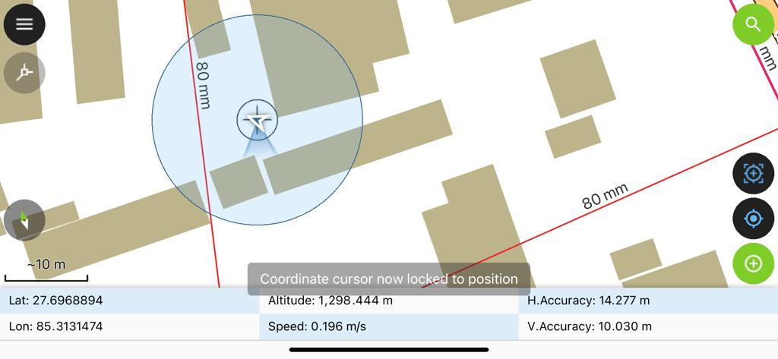
Figure 7: Coordinate Cursor Locked with GPS Location
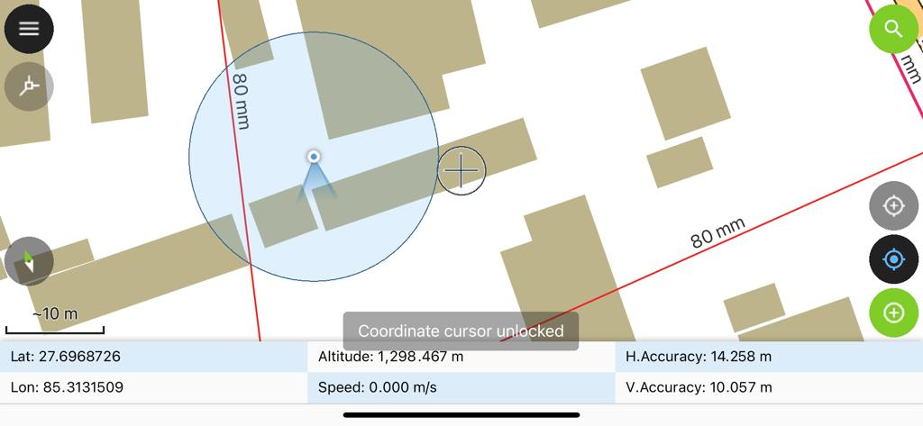
Figure 8: Coordinate cursor unlocked with GPS Location
Navigate the crosshair to the desired location and click the Plus (+) button at the lower right of the screen to confirm the creation of a new point feature. It will pop up the Attribute table to edit.
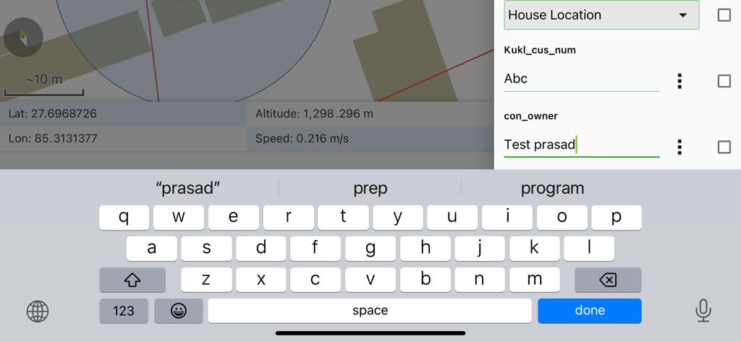
Figure 9: Adding the Attributes of a New Point feature
You can use the lock to position button to force the crosshair to center on your location if you have enabled positioning.

Identify features¶

Fieldwork
Tap on a feature on the map to identify it. If several features are located where you tapped (either because there are multiple features close to one another or because several layers are overlapping), they will all be listed in the menu that opens on the right side of the screen. Otherwise, you can only select one feature at a time. In this example, two features are selected (with Zoom out)
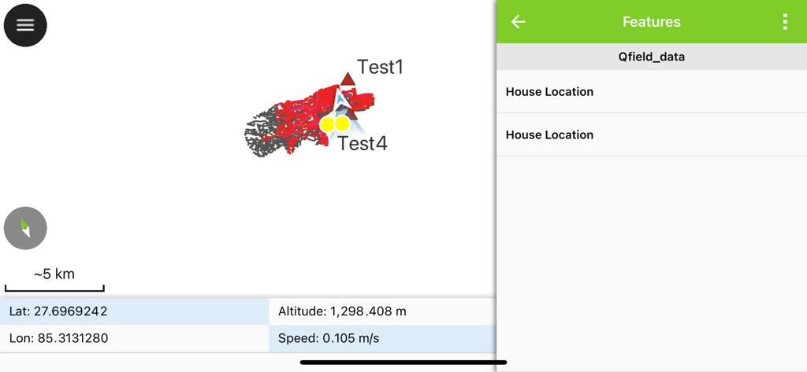
Figure 10: Selection of Features
Tap on one of the listed features to access its attributes.
- Tap the arrows to scroll through all the identified features.
- Tap the centre button to center the map on the selected feature.
- Tap the edit button to edit the attributes of the selected feature.
- Scroll through the sub-menus to access all the attributes.
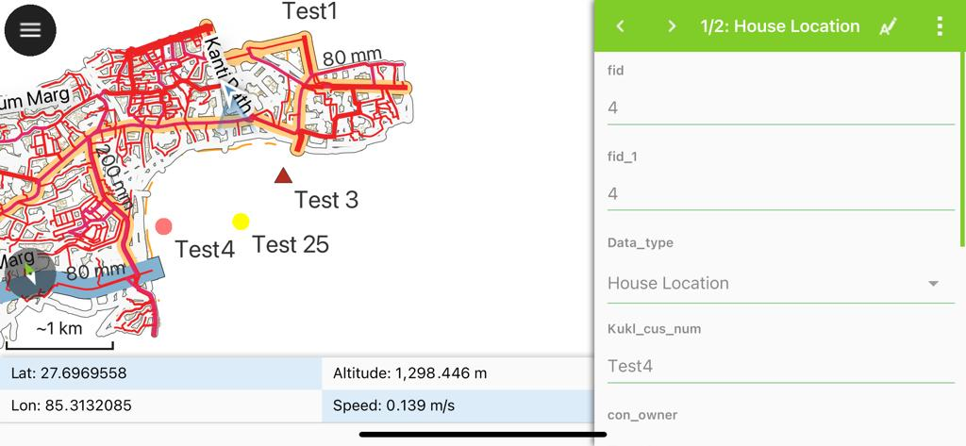
Figure 11:Viewing the Attributes of Selected features
With the Edit Button , you can edit the Attributes.

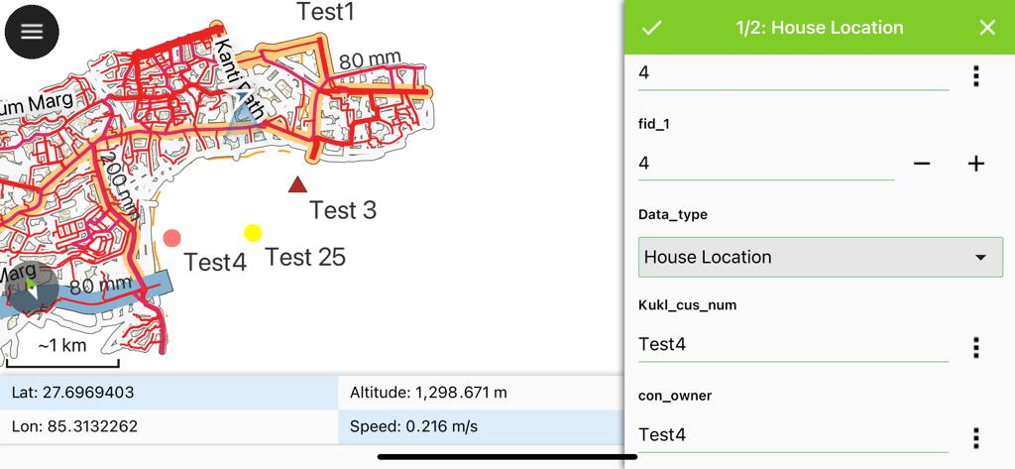
Figure 12: Editing the Attributes of selected features

When features then are selected, you can perform ‘Move the features’, ‘Delete the Features Duplicate the features. The actions are provided in the three-dot-menu on the top right.

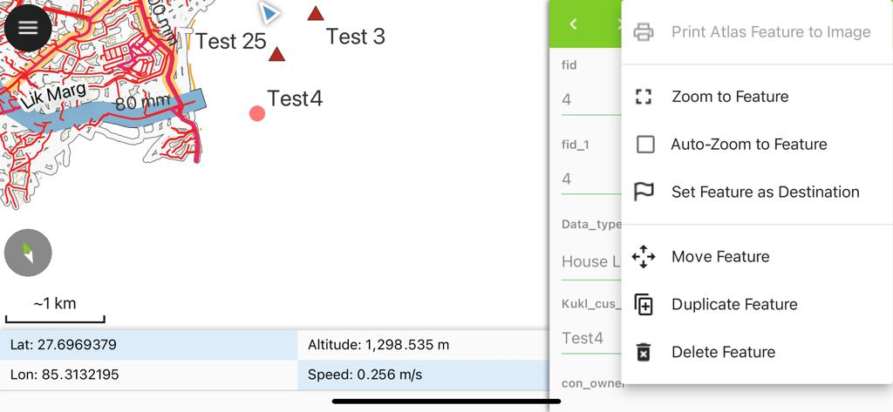
Figure 13: Other Action Available for selected feature
If you Click move Features, you will see a green point, move the map and fix green point at the required location and click green button with right sign  at the lower left above coordinates line. The feature will move to the new location.

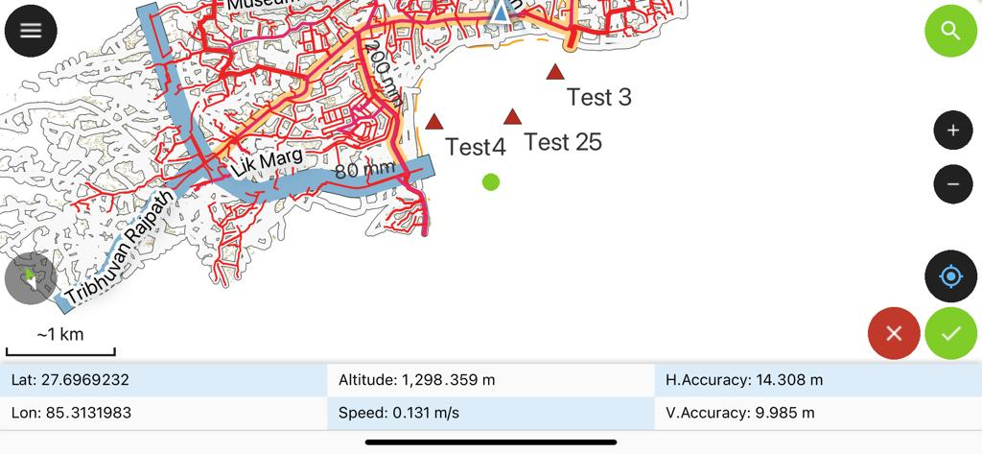
Figure 14: Spatial Editing of the Selected Feature

Miscellaneous Features in the QField Application

Taking the Photograph

After capturing the customer's house location and saving its attributes, the crosshair should be positioned at the house location to capture screenshots. One screenshot should be zoomed in to show nearby roads, while the other screenshot should be zoomed out to provide an overview of the area surrounding the house.
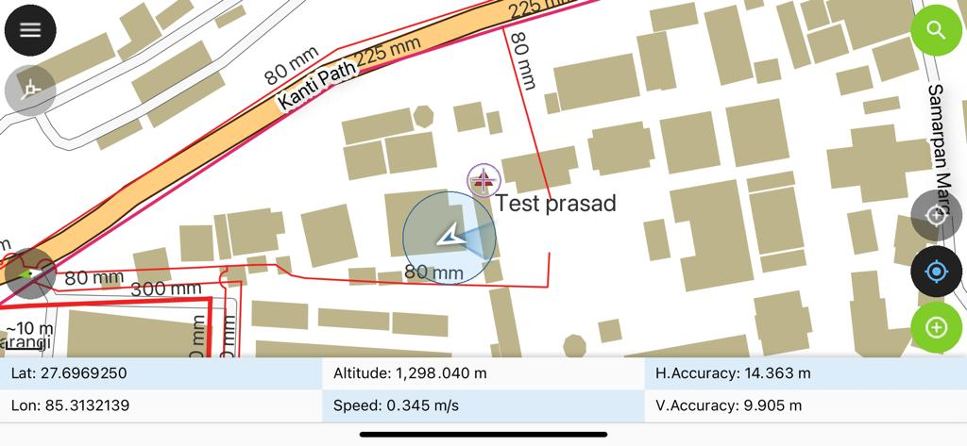
Figure 15: Customer house Location closeup Map with Coordinates

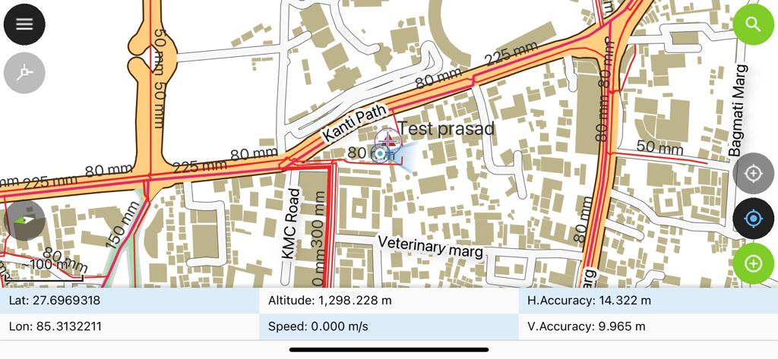
Figure 16: Customer house Location Zoom Out Map with Coordinates

Measuring tool
QField offers measurement functionalities out of the box. To enable the measuring tool, open the main menu and select Measuring Tool.
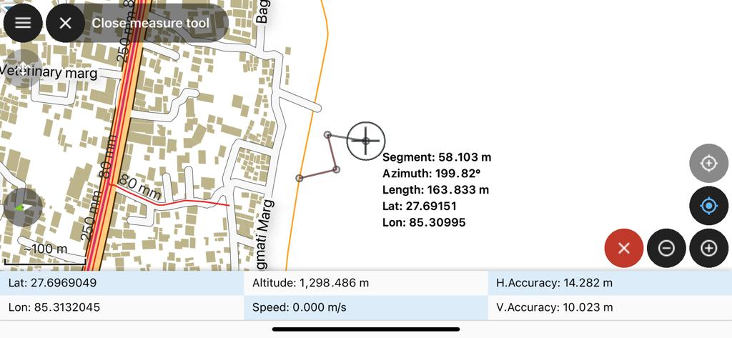
Once the tool is enabled, simply use the digitizing controls located at the lower-right corner of the screen to add and remove vertices. By default, the measured geometry will be a line; to change to a polygon, simply connect the coordinate cursor to the first vertex entered.
For the segment formed of the two last vertices added, details returned include segment length and its azimuth. When the measured geometry is a line, the total line length is provided while the perimeter and area are displayed for polygons.

Lock Screen
QField allows you to lock the screen for added security. To activate the lock screen feature, follow these steps: Open the menu, go to Setup, and select Lock Screen. Once the screen is locked, all functionalities will be disabled. To unlock the screen, simply drag the lock icon from the center towards any direction until it reaches the edge of the circle. The circle will appear once you start moving the lock icon.
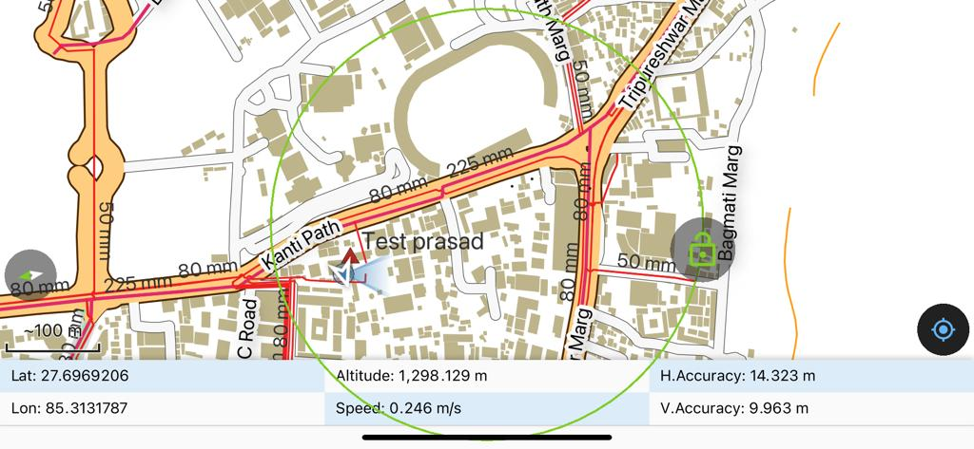
Figure 17: Disabling Lock Screen

Tracking
QField allows you to create points, lines, and polygons from tracking your position.

Activate tracking
To activate tracking, you must first make sure the positioning is active. Then, open the side dashboard, long-press on a legend layer within which you want to save your tracks to, and select the Setup tracking button to configure the tracking session.
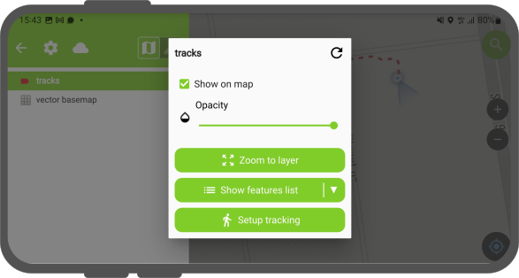
Figure 18: Tracking Setup Menu
Two constraints are available to limit the number of vertices recorded during tracking: - A minimum time interval - A minimum distance
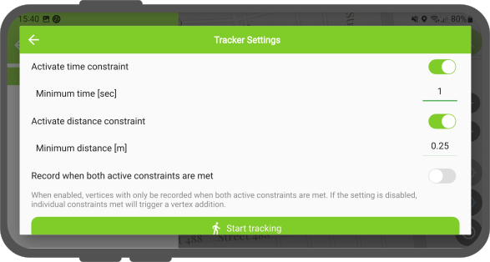
Figure 19: Tracer Settings Menu
Once you have finished configuring your tracking session, hit the Start tracking button to begin recording. At this stage, a feature form will appear, which allows you to define the attributes of the feature(s) that will be created while QField tracks your position.
For line and polygon layers, a single feature - its geometry formed of vertices from the recorded positions - will be create per tracking session. For point layers, a feature will be created for each recorded position, with attribute values entered in the form remembered across features.
QField will skip the feature form step if the layer is configured to hide all attributes or if form has been set to hide on feature addition in the attribute form settings. This can streamline the process of starting tracking sessions.

Tracking underway¶
Once a tracking session has been setup, a badge will appear in the side dashboard legend next to the layer(s) against which tracking is being recorded.
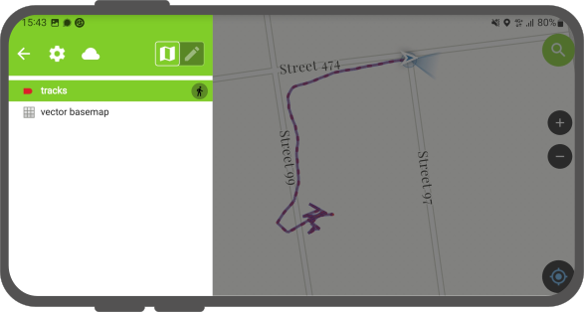
Figure 20: Active Track display
The features created by the tracking session are saved on every vertex recorded. A rubberband line overlayed onto the map is attached to each tracking session, allowing you to glance at what has been recorded.
If the layer linked to a tracking session supports the M dimension, QField will store the time passed since the first vertex recorded in each vertex's M value.
You can simultaneously record multiple trackings sessions across several layers.
While the tracking session is active the layer is still editable, but the tracked feature can't be edited or deleted until the tracking session is stopped over the legend again.

Terminate tracking¶
To terminate tracking, simply open the side dashboard. From there, long-press on a legend layer linked to an active tracking session and select the Stop tracking button.
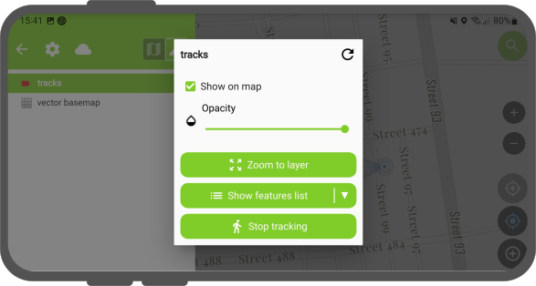
Figure 21: Terminating Tracking Mode

Navigation¶
QField offers navigation functionalities to help orient yourself in the field and accurately reach a given destination.

Activating navigation¶
Navigation is enabled when a destination point has been set and positioning is active. When turned on, a set of navigation overlays - a destination marker, a navigation panel, and a navigation control button - appear over the map.
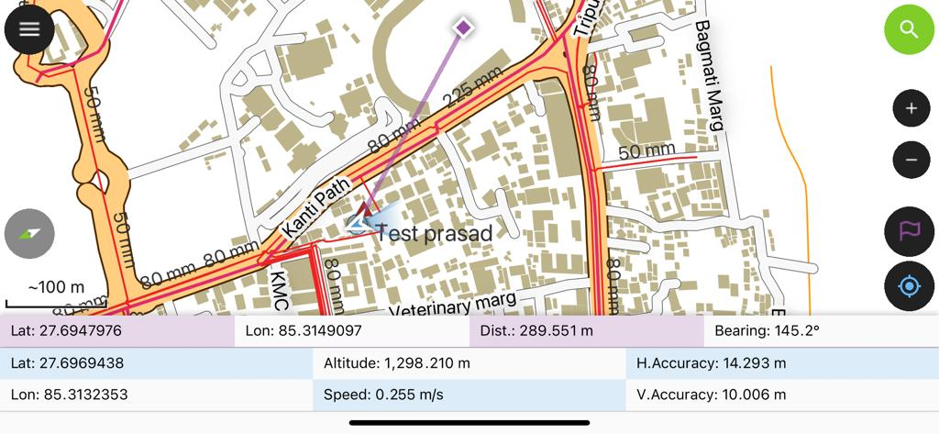
Figure 22: Active Navigation Screen
The navigation panel displays useful information such as the destination point coordinates as well as the current distance and bearing to destination.

Disabling navigation
To disable navigation, clear the destination point by tap and holding on the navigation control button located at the lower right corner.
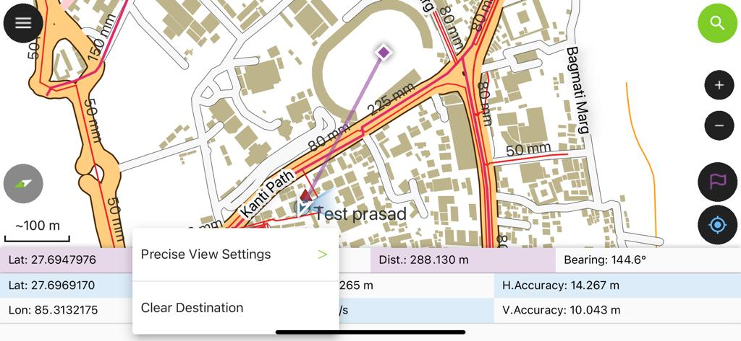
Figure 23: Disabling Navigation

Email The Customer’s Location Screen Shot
Once the customer information is collected, please send the snapshot photos to the data manager via email. The data manager will then affix the snapshots on a template and create a printed document that includes the location map. (Figure 17)

Preparing the Customers House Location Map

A Microsoft Word template has been created for the New House Connection, as shown in Figure 17 (containing all the text information currently used by KUKL). Maps will be attached within the Microsoft Word document using a pre-prepared template. If you are proficient in Nepali typing, please enter the customer details on this page and then proceed with printing. Alternatively, you can print this page with the screenshot maps, leaving space for the customer information to be written by hand

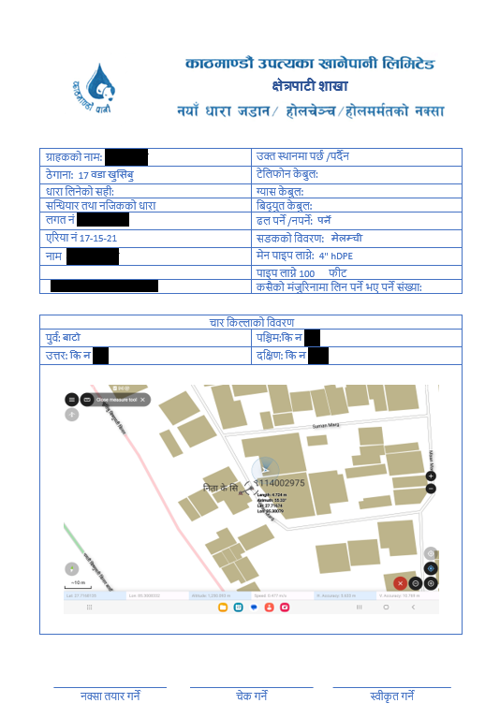
Figure 24: Form for New House Connection / Hole Changed / Hole Repair

