**SOP for Checking Customer Information from GIS and Billing Databases**

1. Open the QGIS and add the layer of “House_connection_end” from the GeoPKG
2. Open the Attribute table of “House_connection_end” layer and activate the edit mode
3. Add a text field to the House connection_end Layer. The Field name is “Fcode” and the length should be 25 characters

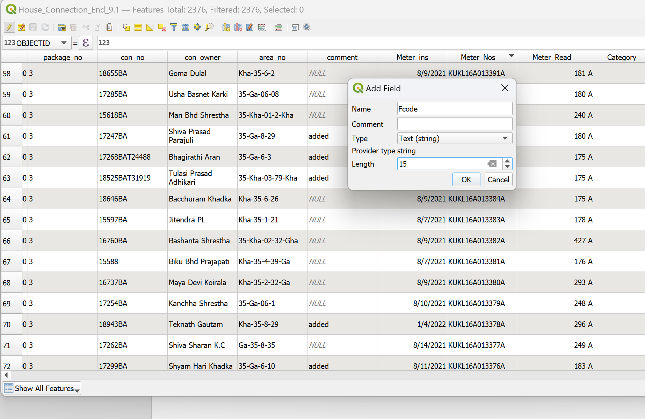

1. Copy the OBJECTID field in the “Fcode” field using the field calculator

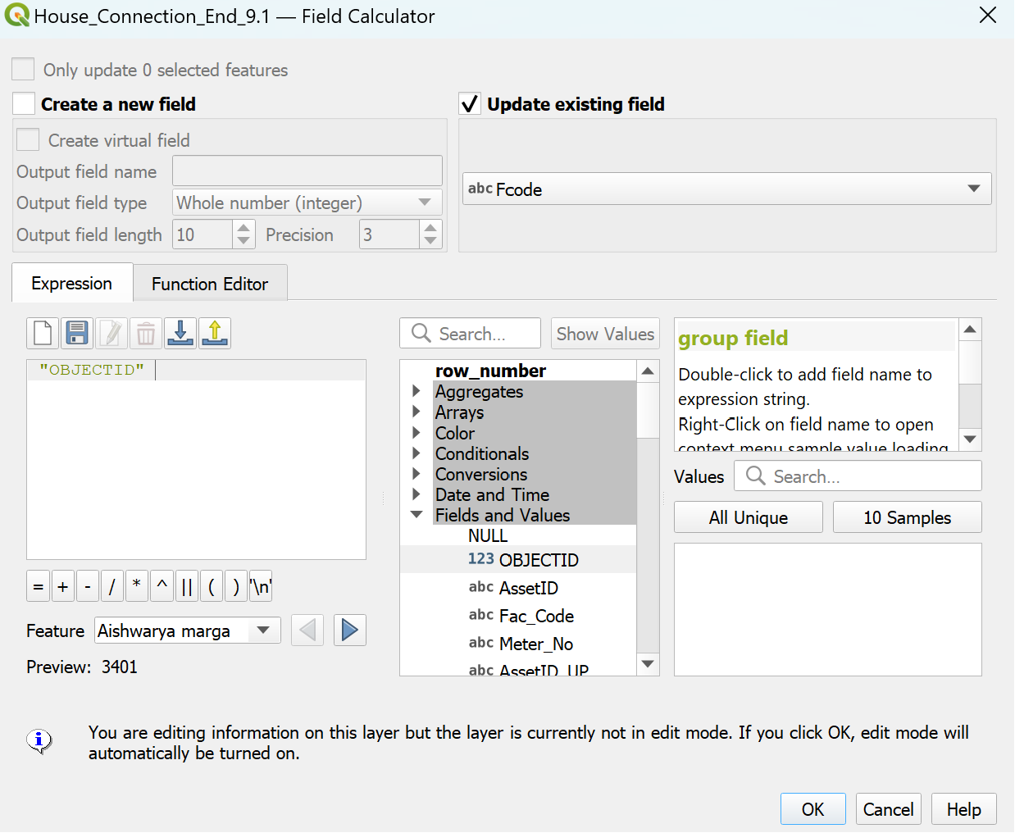

1. Stop the edit mode and save it. Export the attribute table as GIS_91.xls and only select “cus_no”, “cus_owner”, “Address” and “Fcode”

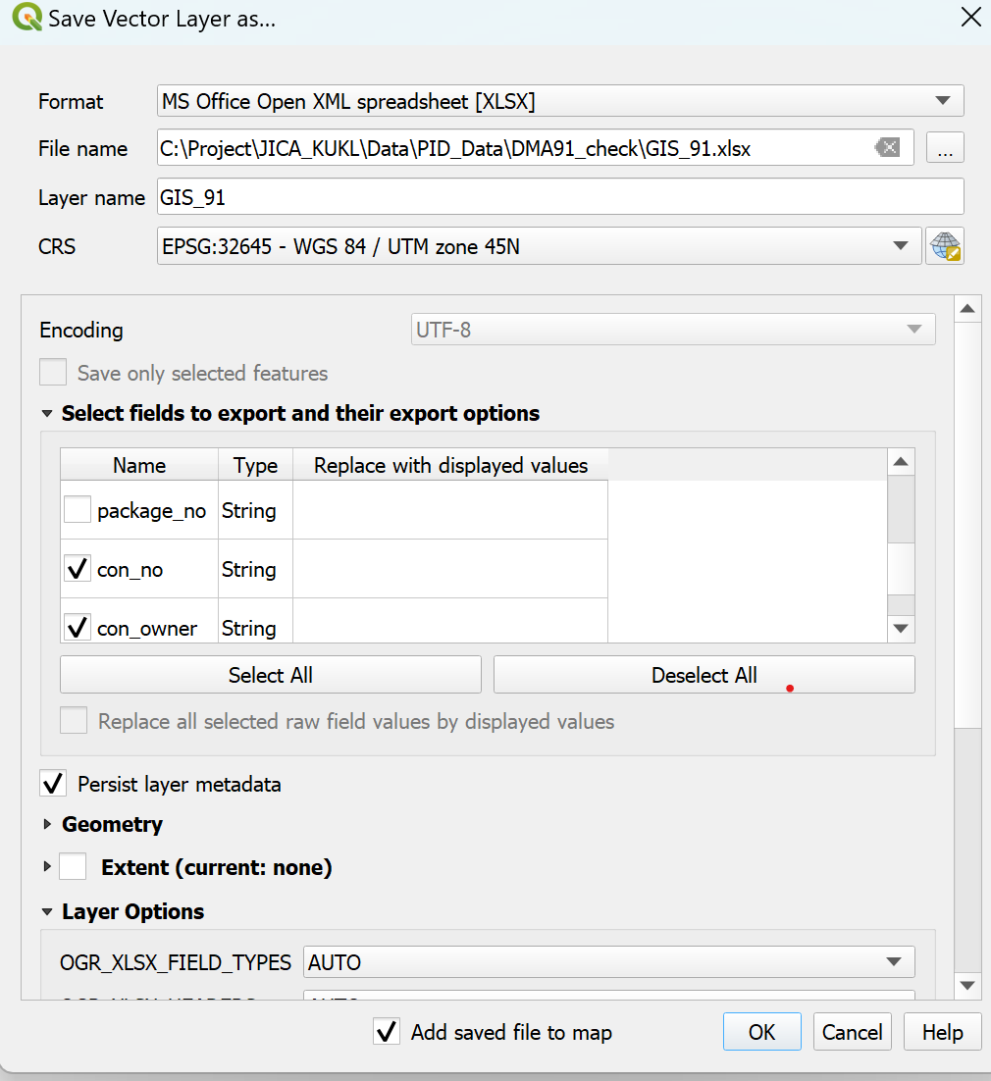

1. From the billing Excel sheet, select only the essential fields and delete others. Now rename the billing fields with the bill prefix as shown below. Please note there should not be any space in the field name (GIS attribute name does not allow space)



Should be changed to



1. Copy the billing Excel sheet in the GIS attribute table as a new sheet. Now, both tables are in one Excel sheet.
2. Create an ID field in Both sheets and copy all the field names in the GIS sheet. Shown as below.

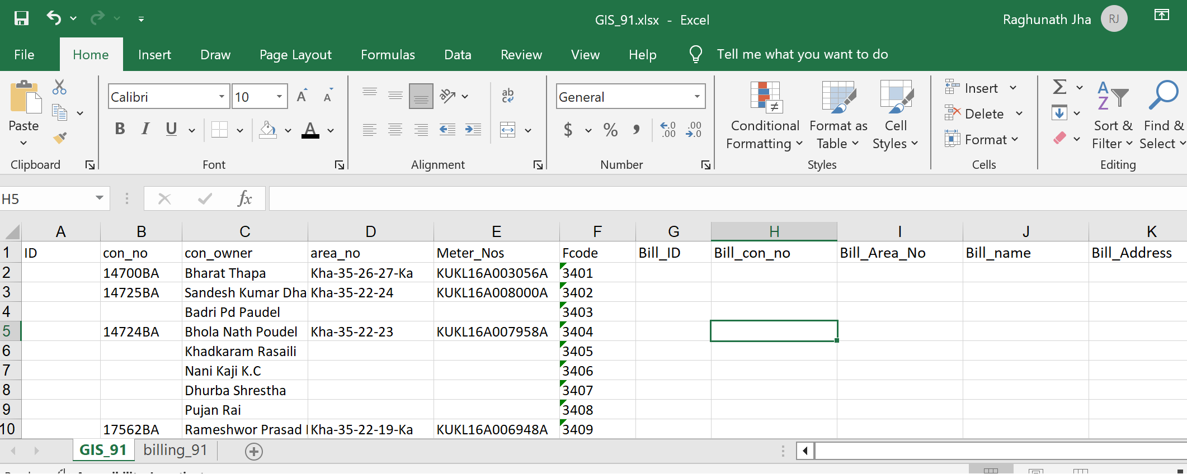

1. In the ID field of GIS_91 use formula =B2 to copy ”con_no” and populate the ID field to the end. In the “Bill_id” field of “Billing_91” sheet use formula = B2 to copy “Bill_con_no” and and populate the “Bill_ID” field to the end.
2. Assigning a name List1 of sheet “billing_9.1” from A2 to E2209 using Menu->Formulas->define Name. We will use this “**list1**” name in the VLOOKUP formula, similarly assign GIS_91 worksheet ranges from A2 to E2377 as **“list2**”

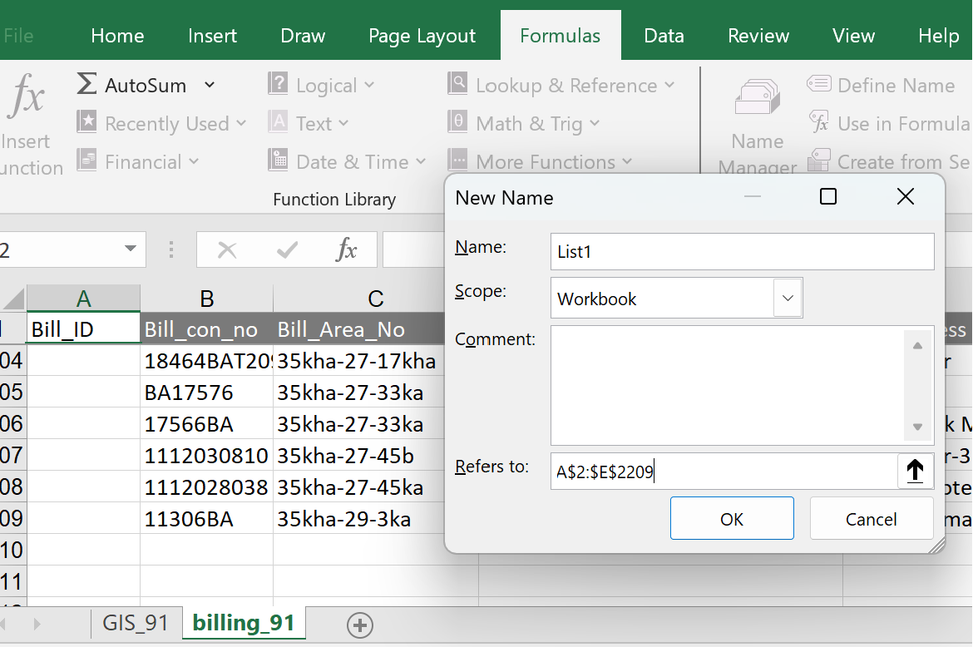

1. VLOOKUP Formula will be used to match the value of the A2 field in the entire sheet of billing_91; if it matches, then put the same value in the “Bill_ID” field. Populate the other right field of the GIS_91, for example, “Bill_con_on”, “Bill_Area_no”, “Bill_name”, “Bill_Adress”.

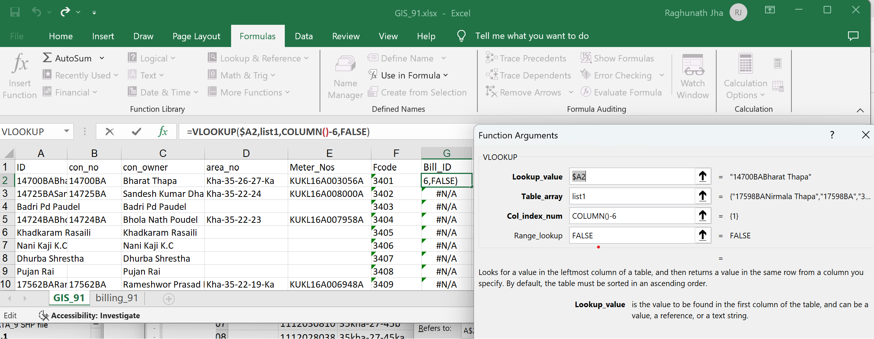

1. Similarly, VLOOKUP formula will be used to match the Value of A2 field of billing_91 worksheet VLOOKUP($A2,list2,COLUMN()-4,FALSE) and populate “con_no”, “con_owner”, “area_no,” “meter_nos” and “Fcode”
2. Copy the all-matches value 1209 from “Bill_con_no” to “Fcode” from “billing_91” worksheet to a new worksheet Matched_record.xls worksheet

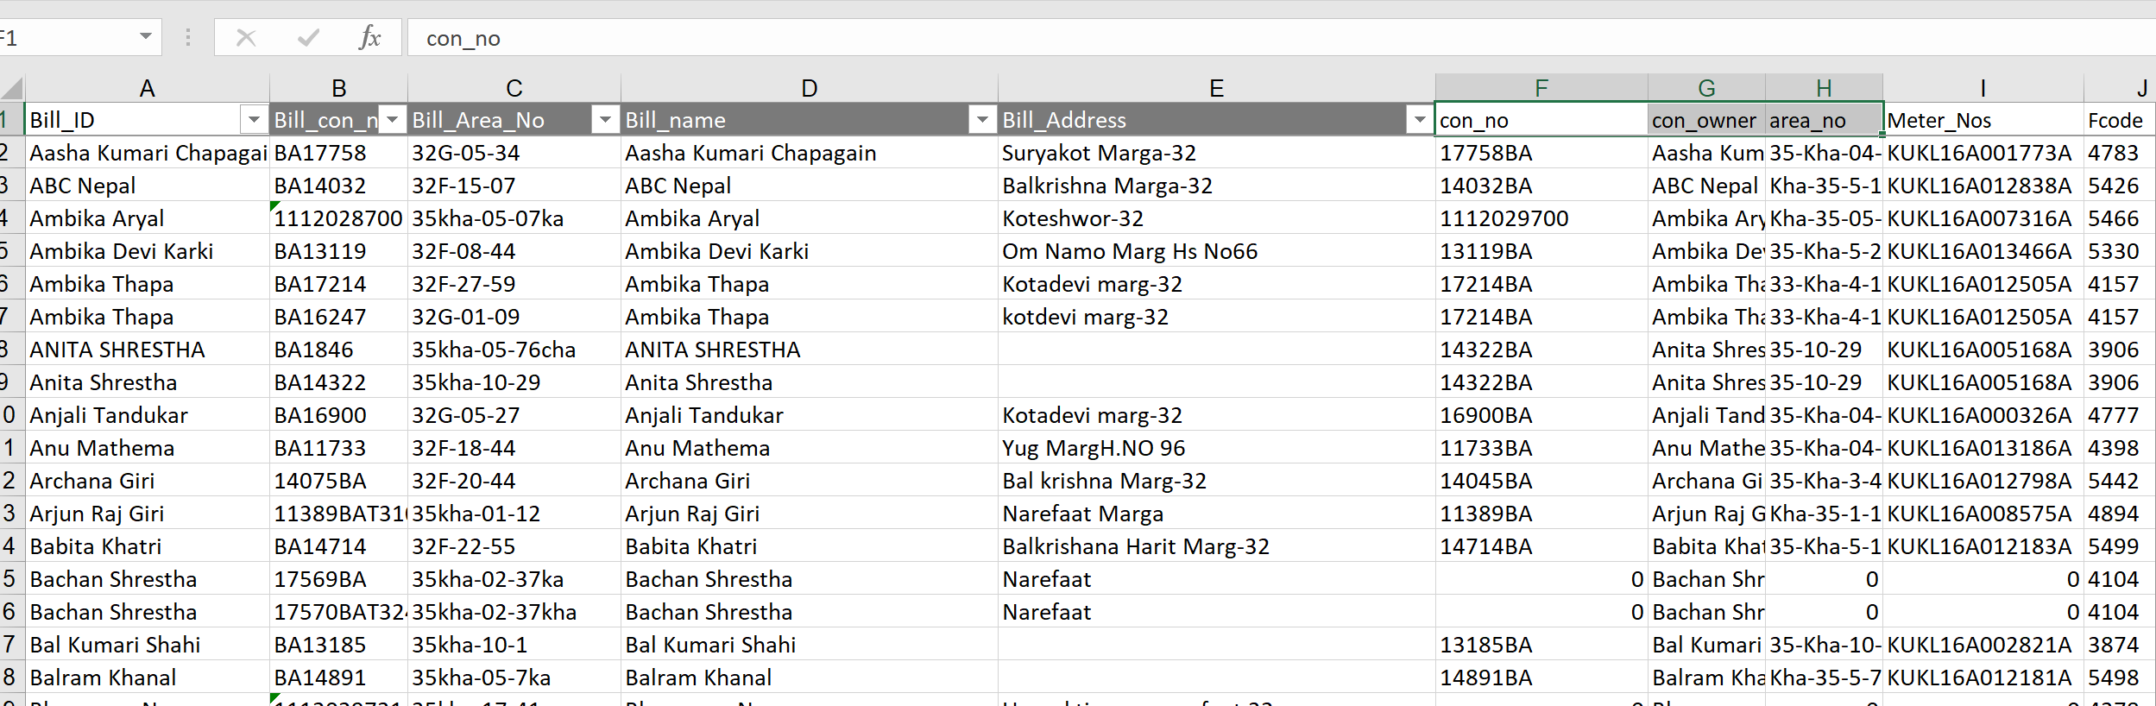

1. Delete the 1209 record from the “billing_91” worksheet and all matches records from “Gis_91”. For deleting, add one field in both worksheets name “delete”, and assign 1 to all match values in both sheets. Delete the matches in the “Gis_91” worksheet. In the “billing_91” worksheet, there will be no match all matches field will be “#N/A”. Select all 1 from the “delete” field and delete it.
2. Do the same with the “Name” field and copy all the match records to a new Table (“Name_matched_record.xls”). This table should be checked for the “customer_number”. Compare the customer numbers of the GIS and billing and update accordingly. Once all records are corrected, merge this table with matched_record.xls. Now we have one table. Save this table in CSV format (comma-separated value) “matched_record.csv”.
3. Open QGIS and add layer “House_connection_end”. Import matched_record.csv in qQGIS using Layer->Add Layer->Add Delimited Text Layer. The new Window will open. In the file name, navigate to the “matched_record.csv”. In the file format, choose comma. Select no Geometry. Finally, Add at the lower right side. The table will be added in the Layer field as shown in Figure below.

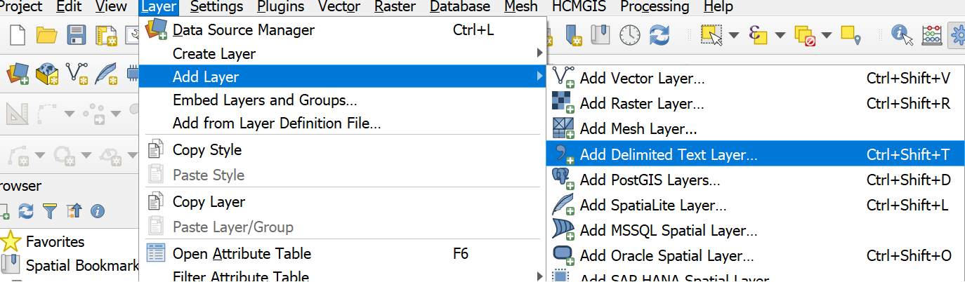

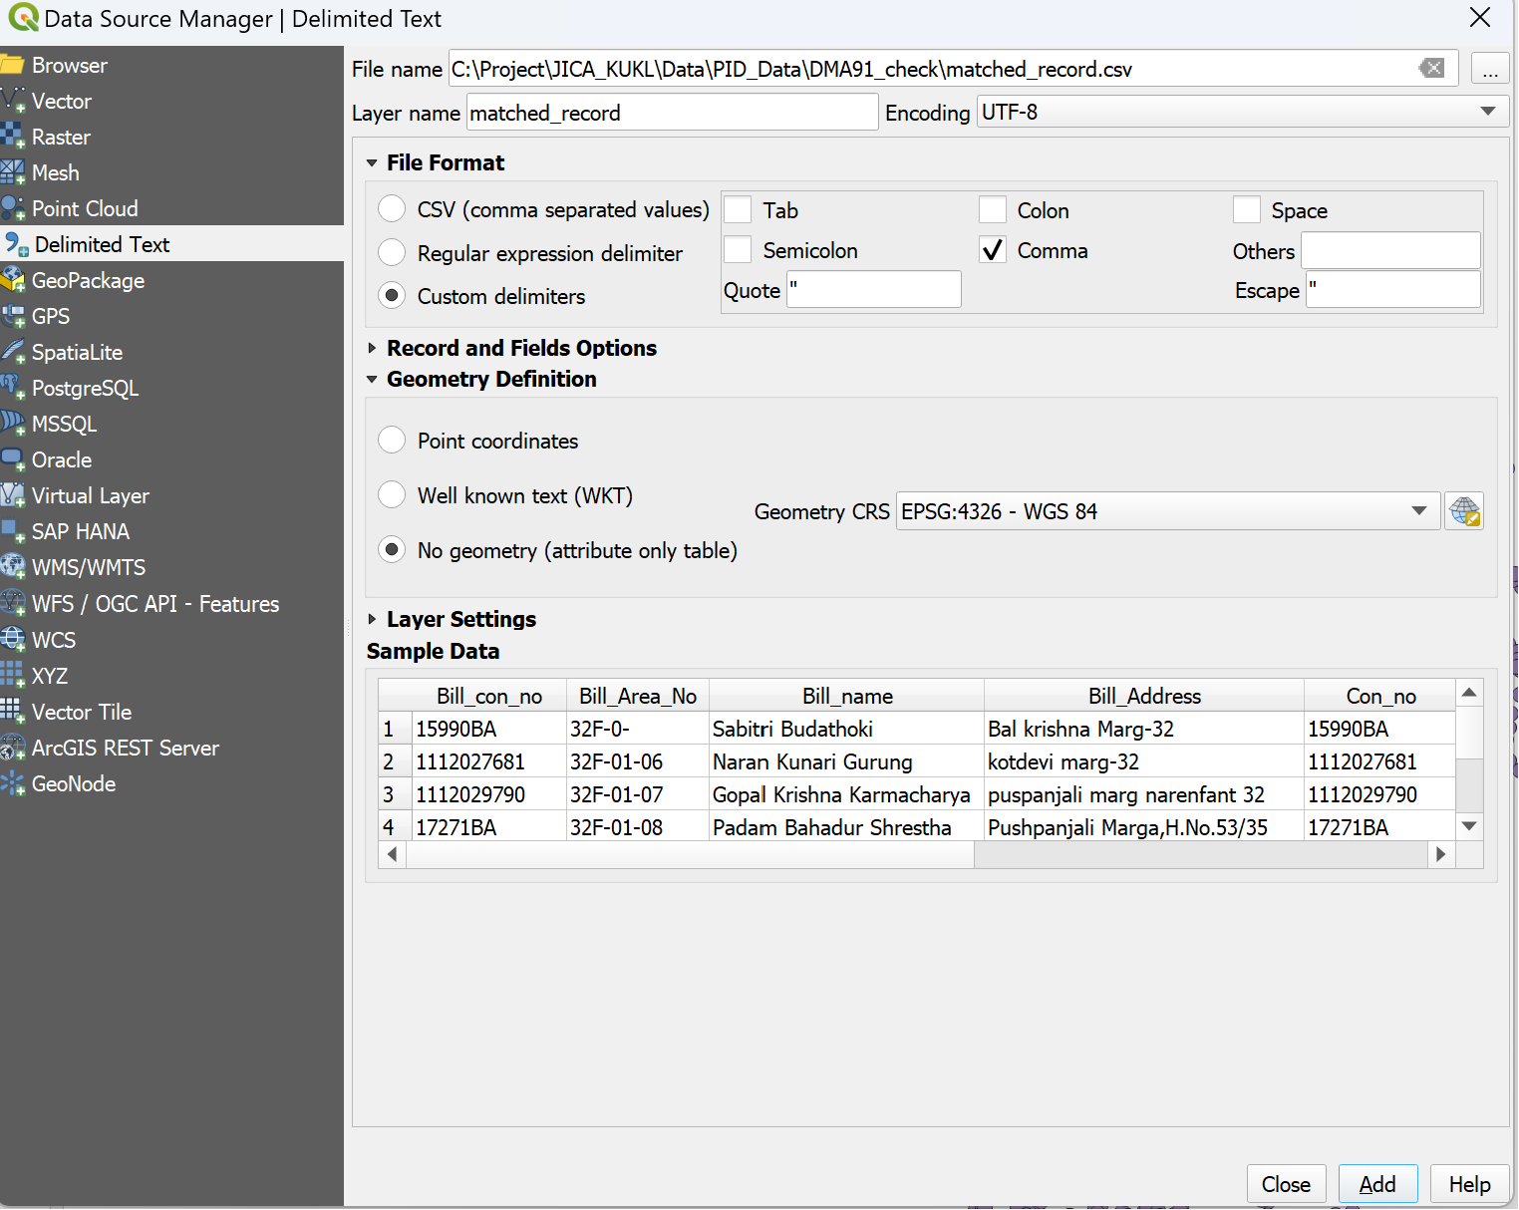

1. Go to “house_connection_end” layer properties (double click at the layer) and click on join. In the Join Layer, select the “matched_record” table; in the join field, select “FCODE,” and in the target field, select “FCODE” (from the “house_connection_end” attribute table). At the “Custom Name Prefix,” first activate it and put “MR_”. This means the field in the “matched_table” attribute will be prefixed with “MR_”; it will be easy to distinguish the layer's own attributes. Click OK. It will join both tables, which can be seen in the attribute table of the “House_connection_end” layer.

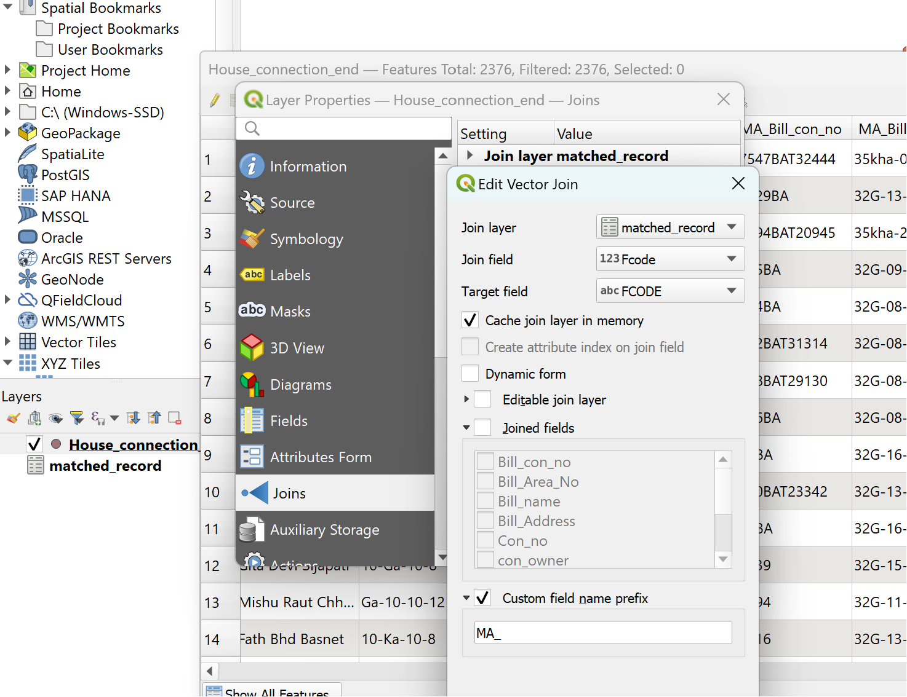

1. This table joining is temporary (in memories only). It will not update the database of the “house_connection_end” layer. After joining the attributes, the table looks like the below figure.

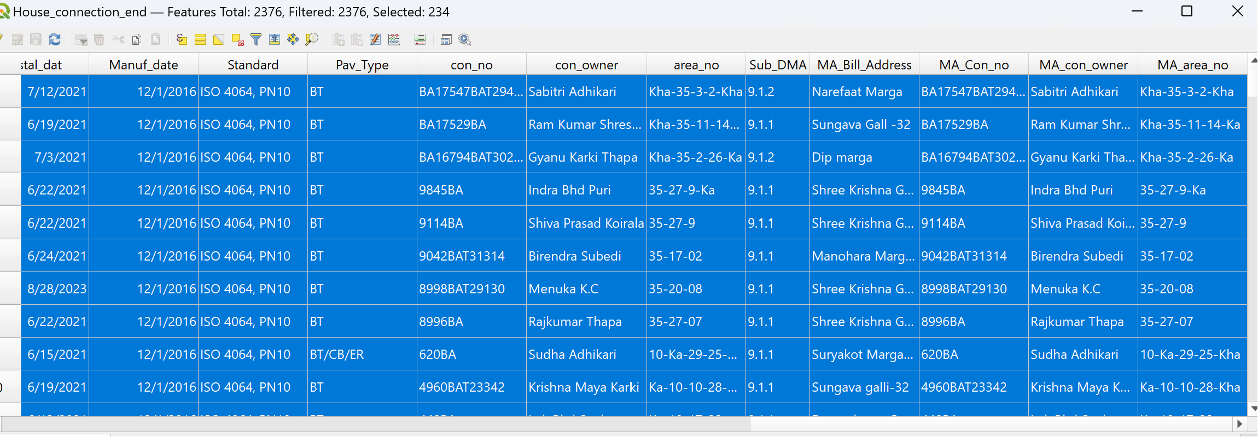

1. Here, it is assumed that the billing “MA_Bill_con_no,” “MA_bill_con_owner, and MA_Bill_area_no” fields are correct, and we have to update GIS (“House_connection_end” layer ) “con_no,” “con_owner and area_no” respectively. First, select records having a value in the field “MA_Bill_con_no” (a null value in this field will not be selected). Open the “FIELD Calculator” tool. Now, update the existing field. Select “con_no” and in the expression field, write “MA_Bill_con_no” and click “OK”. The “con_no” will be updated. Similarly, other two field can be updated. 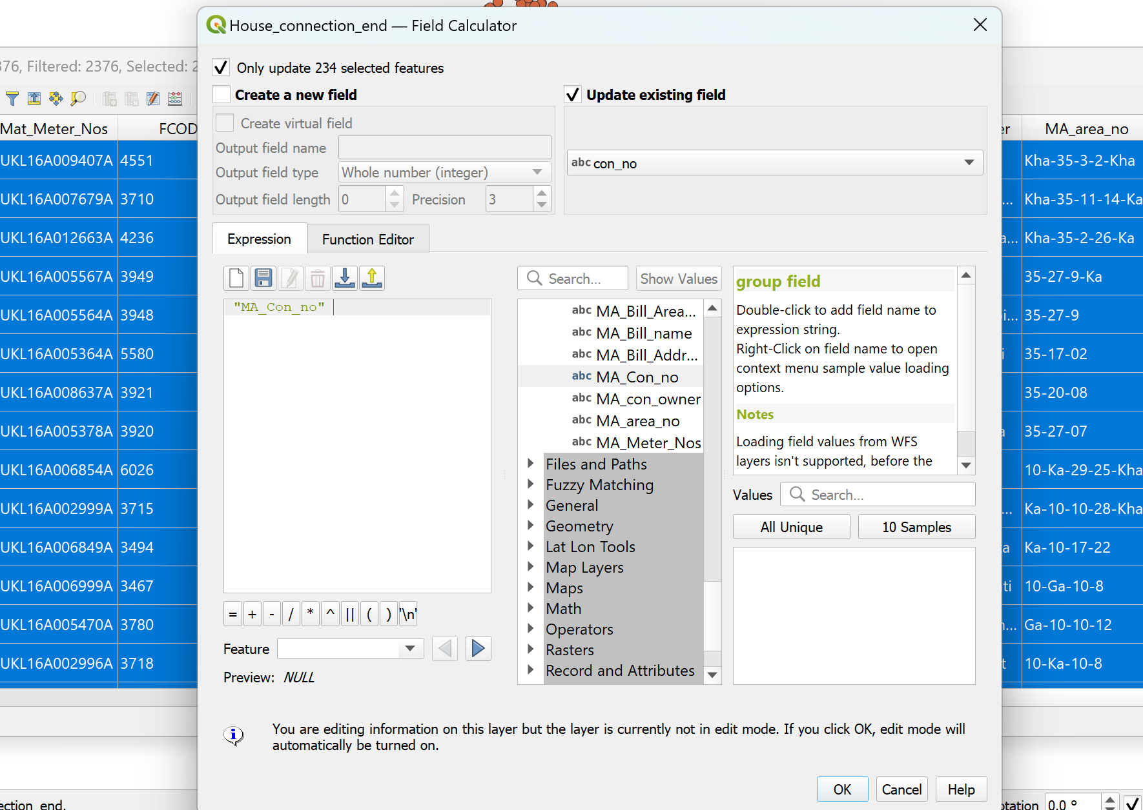
2. Once all fields are updated, remove the table Join. Go to the Property of “House_connection_end” layer. Click join, select the “Join layer matched record” and click  , it will remove selected join.

