The Project on Capacity Development of KUKL to

Improve Overall Water Supply Service in

Kathmandu Valley

Standard Operating Procedures

of

GIS Data Management in KUKL

January 2024

JICA Project Team

Table of contents

0 General 1

0.1 Objectives 1

0.2 Contents of the document 1

0.3 Glossary 2

0.4 On-site cases that GIS can support 4

0.5 Work items 4

0.6 Organization Design of GIS team 5

0.7 Role of the GIS work 5

0.8 GIS & Equipment for Data Maintenance 6

0.9 Structure of GIS Server & Operation PCs 7

0.10 Server Setup Policy 7

1 GIS Data 10

1.1 Overview of GIS data 10

1.2 “GeoPackage” Data format 10

1.3 File/Folder Management 10

1.4 Geometry Type 11

1.5 Layer Management 11

1.6 Attribute Information 12

1.7 Base Map 12

1.8 Positioning Accuracy 13

2 Updating GIS Data 14

2.1 Overview of the Work 14

2.2 Target of the Updating Work 14

2.3 Workflow 15

2.4 Steps for the updating work 15

2.5 Field Data Collection 16

2.6 Data Integration 18

2.7 Data Update 18

3 Quality Check 23

3.1 General 23

3.2 Type of the Quality check 23

3.3 Workflow 25

3.4 Steps for the Quality check 26

3.5 Data Check/ Data Correction/ Quality Inspection 26

4 Information Security 28

4.1 Necessity of Information Security Actions 28

4.2 Actions for Organizations and Companies 28

4.3 What is threat of Information Security? 28

4.4 Impact on organization caused by Information security incidents 29

4.5 Information Assets 30

4.6 Information Security Actions for Geospatial Information and GIS 30

4.7 Priority of Information Security Actions 31

4.8 Actions by Organization 31

Standard Operating Procedures of GIS Data Management in KUKL

# General

## Objectives

This SOP shows standard procedure for creating and maintaining GIS data for water distribution network.

The purpose of this document is to ensure that all the spatial information products created by the GIS team meets the requirements of KUKL GIS data, for data structure, accuracy, symbology and attribute information. However, it is important to note that not all information described herein will apply directly to every cases.

This document shows a standard data specification and procedures and supplementary information to assist GIS team and engineers in KUKL, and contractors, which can be applied to any activity that generates spatial information of Water distribution facility assets that belong to KUKL.

## Contents of the document

The contents of this book are as follows. By understanding and implementing these items, aim to be able to create and maintain data that meets the required quality.

|  |  |
| --- | --- |
| Items | Contents |
| General | Objectives/ Contents of the document/ Glossary/ On-site cases that GIS can support/ Work items/ Organization Design of GIS team/ Role of the GIS work/ GIS & Equipment for Data Maintenance/ Structure of GIS Server & Operation PCs/ |
| GIS Data | Overview of GIS data/ “GeoPackage” Data format/ File/Folder Management/ Geometry Type/ Layer Management/ Attribute Information/ Base Map/ Positioning Accuracy |
| Updating GIS Data | Target of the Updating Work/ Workflow/ Steps for the updating work/ Field Data Collection/ Data Integration/ Data Update |
| Quality Check | Type of the Quality check/ Workflow/ Steps for the Quality check/ Data Check/ Data Correction/ Quality Inspection |
| Information Security | Necessity of Information Security Actions/ Actions for Organizations and Companies/ What is threat of Information Security?/ Impact on organization caused by Information security incidents/ Information Assets/ Information Security Actions for Geospatial Information and GIS/ Priority of Information Security Actions/ Actions by Organization/ |

## Glossary

**[GIS]**

A “Geographic Information System (GIS)” is a type of database containing geographic data (that is, descriptions of phenomena for which location is relevant), combined with software tools for managing, analyzing, and visualizing those data.

GIS provides the capability to relate previously unrelated information, through the use of location as the “key index variable”. Locations and extents that are found in the Earth's spacetime are able to be recorded through the date and time of occurrence, along with x, y, and z coordinates; representing, longitude (x), latitude (y), and elevation (z). All Earth-based, spatial–temporal, location and extent references should be relatable to one another, and ultimately, to a “real” physical location or extent. This key characteristic of GIS has begun to open new avenues of scientific inquiry and studies.

**[Layer]**

GIS can display multiple different drawings in one place, like overlapping “transparent sheets”. Each of these multiple different drawings, such as a “transparent sheet”, is called a “Layer”. With GIS, it is possible to display/hide figures on a layer-by-layer basis, set line types and colors, enable/disable editing, search and display using the attribute information of each layer, etc.

**[Database]**

A “Database” is information collected under specific conditions that is organized (structured) in a fixed format. It refers to a collection of data that is organized for the purpose of not only storing data, but also searching, extracting, sharing, and processing the stored data.

**[Table/Record/Field]**

'Table' is essential object in a database to store all the information or data. 'Table' is also used in an attribute table on GIS application. A table has records (rows) and fields (columns).

Basics of Table/Record/Field

* Each field has a data type, such as integer, decimal number, string, and date.
* Users can enter field values that match the data format defined in each field.
* Same type of information must be entered in one field.

Field value of the “Phone number” must not be entered in the “Name” field.

* Field value entered in a record must be related to value in other field in the same record.

“Phone number” of “Bcd Efg” must not be entered in the record of “Abc Def”.

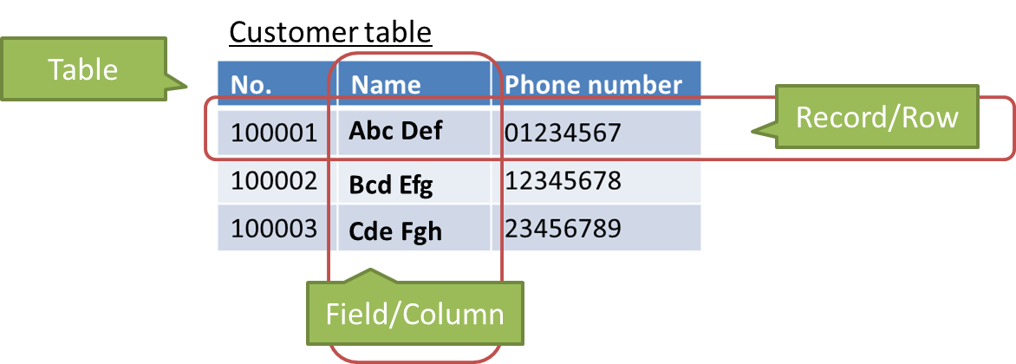

**[Geospatial]**

“Geospatial information” is information indicating the location of a specific point or area in space (location information) and information about various events or objects associated with location information.

**[Spatial database]**

A “Spatial database” is a database optimized to store, query, and manipulate geospatial objects defined in geometric space, such as vector and raster data. User can store all your data in one big file, rather than as a set of separate files. This makes data organization and sharing easier. Various geospatial data stored in geospatial databases can be analyzed using GIS.

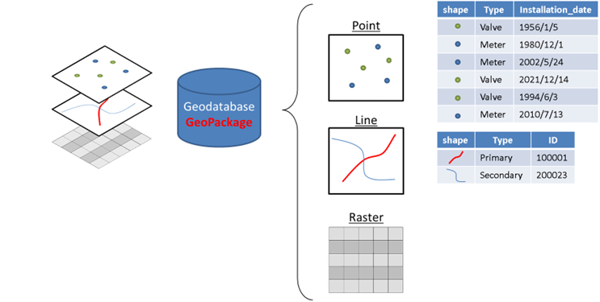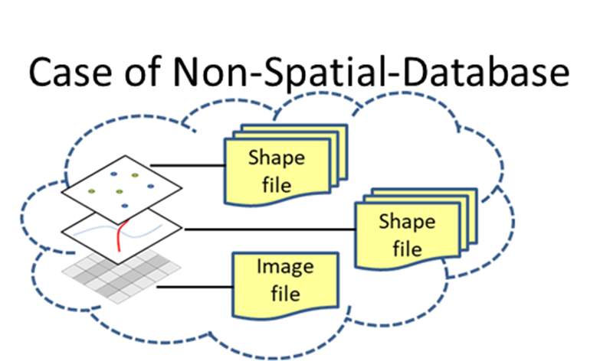

**[Geodatabase]**

The clearest difference between Geodatabase and shape file for a user is that a shape file is a one-drawing-feature-storage format. So, a shapefile generally contains just one drawing feature with a set of attributes or fields. Geodatabase also contains drawing features, but it allows user to add more than one to it. So, it allows you to create a database consisting of multiple drawing features or tables to it. Geodatabase is a container for spatial data sets.

**[GeoPackage]**

GeoPackage (GPKG) is one of the spatial database formats and an open, non-proprietary, platform-independent and standards-based data format for GIS built as a set of conventions over an SQLite database. Defined by the Open Geospatial Consortium (OGC) with the backing of the US military, GeoPackage has seen widespread support from various government, commercial, and open-source organizations.

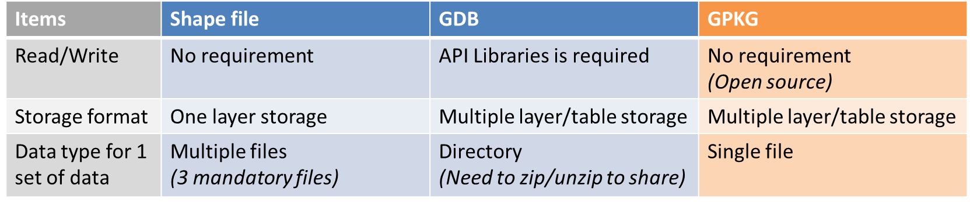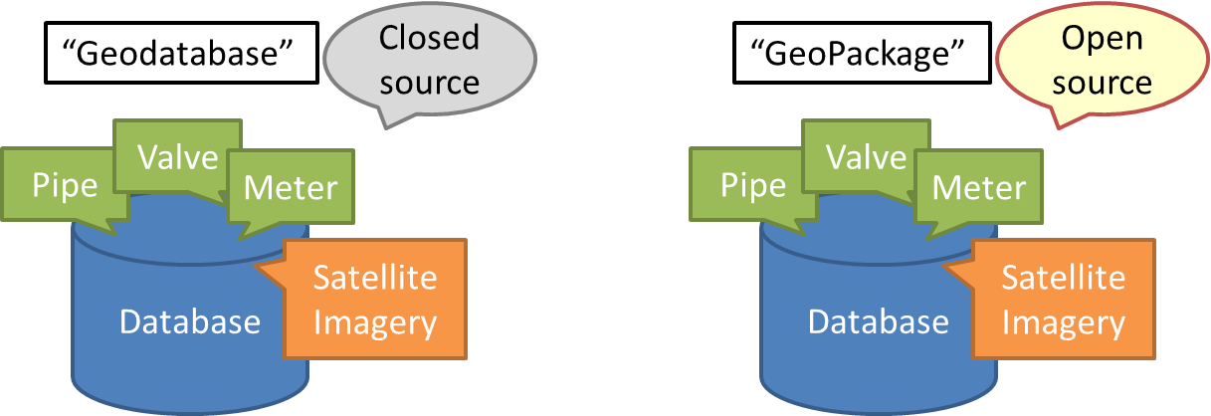

## On-site cases that GIS can support

GIS helps your work in the case of on-site activities, as listed below:

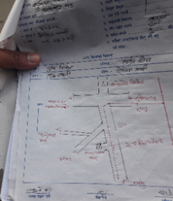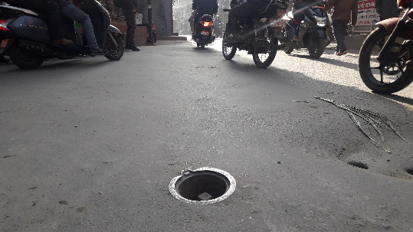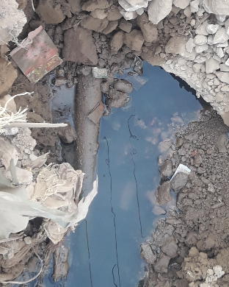

* Locate existing underground pipes/valves.
* Locate leaking place or polluted place as per the customers’ reporting.
* Record and archive digitally the current situation (for next generations).
* Analyze the damage in the affected area.
* Locate place of the house connection.
* Get customer information from place of the house connection.
* Make new plan, new installation, replacement, extension.
* and more….

## Work items

The General work items of GIS data maintenance are shown below. The detail of the work is shown in each chapter.

|  |  |
| --- | --- |
| Items | Description |
| 1. Map preparation | Base map for updating work (new installation/replacement/repairment) |
| 1. Collecting field information | Measure/collect information of the facilities to be updated on site |
| 1. Importing field information | Import/validate collected information |
| 1. Updating GIS data | Update (add/modify/remove) the GIS data |
| 1. Quality management | Inspect the updated data to conform to the product standard |
| 1. Maintenance of GIS data | Back up/Update/Organaize the GIS data |
| 1. Maintenance of Hardware/Software |  |

## Organization Design of GIS team

This shows the structure of the GIS work team at KUKL. The Head Office handles management aspects related to GIS work, such as data maintenance and management such as GIS data integration, backup, and quality inspection, maintenance and management of GIS-related equipment and hardware/software, planning and implementation of training, and collaboration with the IT section. Each branch office strives to keep the site situation and GIS data in the same state at all times by collecting information that is updated on a daily basis and updating the GIS data. The IT section is responsible for maintaining and managing the IT environment, including KUKL's internal network and GIS dedicated servers, to ensure smooth data sharing between the headquarters and each branch office.

**GIS Team @Head Office**



IT Section @Head Office

Update Daily data

Maintenance of GIS data & equipment

Technical Training

Coordination for IT environment

Mahankalchaur

Maharajgunj

Baneshwor

Tripureshwor

Lalitpur



## Role of the GIS work

The role of GIS data maintenance is shown. Data collection in the field, updating data at office, Data management at HO, Working collaboratively involving a group of people is important in order to achieve a common goal.

|  |  |  |
| --- | --- | --- |
| Items | Branch office (Updating) | Head office (Management) |
| Collecting field data | Yes |  |
| Updating field data | Yes |  |
| Checking updated data | Yes |  |
| Integrating all branch’s data |  | Yes |
| Inspecting updated data |  | Yes |
| Backup GIS data | Yes | Yes |
| Taking initiative and addressing technical issues | Yes | Yes |
| Coordination with IT section |  | Yes |
| Updating SOP and related technical document | Yes | Yes |

## GIS & Equipment for Data Maintenance

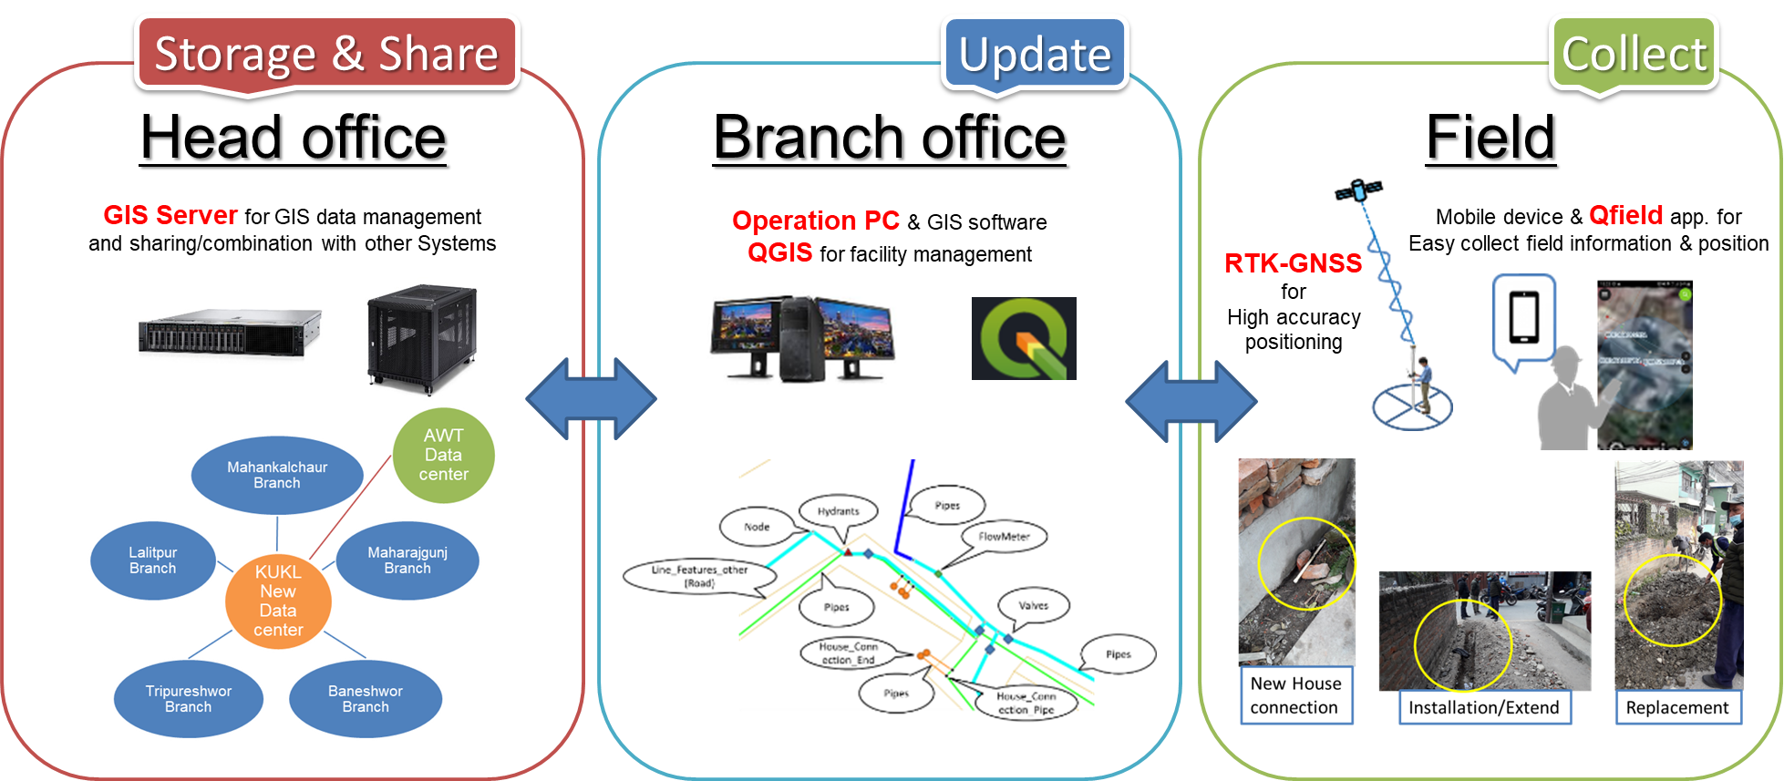

* **GIS Server** for GIS data management and sharing/integration with branch office using internal network
* **Operation PC and GIS software such as QGIS** for water supply facilities management
* **Mobile device with QField app.** for easy collecting field information
* **RTK-GNSS** for easy measuring positioning with high accuracy

## Structure of GIS Server & Operation PCs

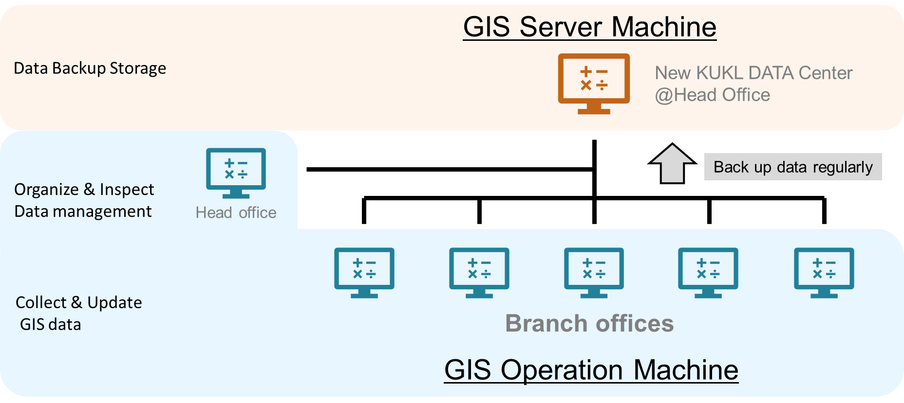

## Server Setup Policy

When operating a data server within an organization, it is important to implement "access rights settings" that define operating privileges for folders and files as an information security measure to prevent information leaks and accidental deletion of data.

Using a data server without setting permissions allows all users to access all files and folders. It is dangerous for anyone to be able to view and use confidential information from other departments and personal information related to human resources. In some cases, your information may be stolen or unintentionally disclosed by a malicious user.

Additionally, if access rights are not set, erroneous operations such as accidentally deleting or overwriting important files may cause serious problems or business delays. Additionally, if anyone is allowed to freely create files and folders, administrators will no longer be able to manage them and the load on the server will increase.

Setting access rights in advance is important for employees to perform their work safely, prevent information leaks and human errors, and reduce the burden of managing files and folders.

* Access right

It can only be set by some administrators and administrator groups with administrator privileges on the system, and is set per user and group. Permissions are required to access the system and create, write, or delete files.

* Types of data server access rights

By default, all privileges are granted to all users.

There are generally three types of permissions: read, modify, and full control.

**"Read" permission**: List files and folders, read files only.

**"Modify" permission**: In addition to "read" permission, you can create, edit (overwrite), and delete files, and create folders and files under them.

**“Full Control”**: 'Read' and 'Modify' permissions, plus the ability to change ownership and access settings.

* Data server permission settings

1. Decide on your folder structure

Decide on the folder structure according to your company's business, such as for each project or department.

2. Create a user account

Create an account by setting a username and password for the person who will be using the data server. Management and operation will be easier if the user name is created according to certain rules, such as employee ID + name (in Roman letters).

3. Add users to groups

Create a group for which you want to set access rights separately from users, and add users to that group.

Management is made easier by setting up groups for each department, position, or project.

4. Set access rights for each folder

If you want to set access rights for each folder, set them for each group.

* Data server permission settings in KUKL

1. The branch/head office have full access in their respective directory. The BO cannot navigate to the other BO/HO directories.
2. The HO, can see all the directories/files of all BO in the server but cannot delete them (Read-only)
3. The password of the Administrator should be known to JICA and IT.
4. The archive directory is created outside the HO directory in the server. and all users should have read access. HO should have full access.
5. HO can create and copy sub-directories/files in the archive directory but cannot delete them.
6. The delete option in the archive directory should only available with administrative user.

Directory permissions matrix

|  |  |  |  |  |  |
| --- | --- | --- | --- | --- | --- |
| Directory | User | Read | Create | Edit | Delete |
| BO | BO | Yes | Yes | Yes | Yes |
| Other BO | No | No | No | No |
| HO | Yes | No | No | No |
| Admin | Yes | Yes | Yes | Yes |
| guest | No | No | No | No |
| JICA | Yes | No | No | No |

|  |  |  |  |  |  |
| --- | --- | --- | --- | --- | --- |
| Directory | User | Read | Create | Edit | Delete |
| HO | BO | No | No | No | No |
| HO | Yes | Yes | Yes | Yes |
| Admin | Yes | Yes | Yes | Yes |
| guest | No | No | No | No |
| JICA | Yes | No | No | No |

|  |  |  |  |  |  |
| --- | --- | --- | --- | --- | --- |
| Directory | User | Read | Create | Edit | Delete |
| Archive | BO | Yes | No | No | No |
| HO | Yes | Yes | Yes | No |
| Admin | Yes | Yes | Yes | Yes |
| guest | No | No | No | No |
| JICA | Yes | No | No | No |

|  |  |  |  |  |  |
| --- | --- | --- | --- | --- | --- |
| Directory | User | Read | Create | Edit | Delete |
| JICA | BO | Yes | No | No | No |
| HO | Yes | No | No | No |
| Admin | Yes | Yes | Yes | Yes |
| guest | No | No | No | No |
| JICA | Yes | Yes | Yes | Yes |

|  |  |  |  |  |  |
| --- | --- | --- | --- | --- | --- |
| Directory | User | Read | Create | Edit | Delete |
| Materials | BO | Yes | No | No | No |
| HO | Yes | Yes | Yes | Yes |
| Admin | Yes | Yes | Yes | Yes |
| guest | Yes | No | No | No |
| JICA | Yes | No | No | No |

|  |  |  |  |  |  |
| --- | --- | --- | --- | --- | --- |
| Directory | User | Read | Create | Edit | Delete |
| Others | BO | No | No | No | No |
| HO | No | No | No | No |
| Admin | Yes | Yes | Yes | Yes |
| guest | No | No | No | No |
| JICA | Yes | No | No | No |

[Operation flow] (figure of the flow/roll will be created in SOP)

* If the branch loses the latest GIS data, will navigate to the server archive directory and copy the latest data in their local computer.

* Update the GIS data with the contents what has been updated in the field/document since the last archived data was stored.

* After updating the data at branch, the branch will copy the data to the branch directory in the server.

* The head office GIS member will copy the branch GIS data from the branch directory to the head office directory.

* After inspecting the data at head office, head office will copy the inspected data to the branch directory.

* The branch will take and copy the inspected data from the branch directory in the server to the branch client machine.

* After correcting the data at branch, the branch will copy the data to the branch directory in the server, again.

(The branch can delete unnecessary data in the branch directory in the server.)

* When all the corrections are completed of that term, head office will copy the corrected data to the archive directory of that term in the server.

# GIS Data

## Overview of GIS data

Overview of GIS data for the Water distribution network conplied to the product specifications.

|  |  |  |
| --- | --- | --- |
| **Item** | **Description** | **Remarks** |
| Data format of Original data | Geodatabase | Official data from PID |
| Data format of daily update work | **Geopackage** |  |
| CRS (Coordinate Reference System) | **EPSG:32645 - WGS 84 / UTM zone 45N - Projected** |  |
| Dimension | **2D** |  |
| Unit | **Meters** | Map data |
| Data collection method | Ground survey measurement | (RTK/Measuring Tape, etc.) |
| Geometry type | Point/Line/Polygon |  |
| Feature contents | FlowMeter/House_Connection_End/House_Connection_Pipe/Valves/Pipes/Hydrants/Line_Features_other/Service_Reservoir/Node |  |

## “GeoPackage” Data format

The GIS data shall be maintained in “**GeoPackage**” format.

The GIS data format of the new water distribution network provided from DNI project will be “Geodatabase” (GDB). In terms of convenient and efficient GIS data maintenance, one of the major geospatial format “GeoPackage” (GPKG) will be used with QGIS for the daily GIS work.

## File/Folder Management

For the file unit of GIS data, one GeoPackage is created for each sDMA managed by each branch to maintain and manage the data. The naming conventions for file and folder names of GIS data updated at branch offices shall follow the rules below.

* Example of folder name:

Folder name: *KUKL_TP*

* Example of file name:

The latest GPKG file name: *KUKL_TP.gpkg*

(*Always the latest file must be updated.)

Backup File name: *KUKL_TP_20220815.gpkg*

* Branch office abbreviation:

**MH**: Maharajgunj Branch

**MK**: Mahankalchaur Branch

**TP**: Tripureshwor Branch

**BN**: Baneshwor Branch

**LP**: Lalitpur Branch

**CH: Chhetrapati Branch**

## Geometry Type

The geometry type of GIS data shall be points, lines, or polygons.

**Specific creation rules and notes for each geometry type**

|  |  |
| --- | --- |
| **Type** | **Remarks/ Data creation rule** |
| Point | * The center of the point shall be placed at the center position of the target facility or at the typical position of the target facility where is determined on site. * When creating points, do not use lines or curves. |
| Line | * The center line shall be placed at the center line of the target facility or at the typical line of the target facility where is determined on site. * When creating a line, do not use curves (circles, oval, oval arcs, springs, crosoids, etc.). * When expressing a curved shape, draw line with vertex. * Divide the line in a part where the attribute information is different. * Do not create twisted line data. * When connecting to other adjacent lines, the coordinates of the end points of each line at the connection point must match. |
| Polygon | * The polygon line (extent) shall be placed at the boundary line of the target facility or at the typical outer line of the target facility where is determined on site. * When creating a polygon, do not use lines or curves (circles, oval, oval arcs, springs, crosoids, etc.). * Divide the polygons in a part where the attribute information is different. * Do not create twist polygon data. * Gap or overlap should not be between the adjacent polygon |

## Layer Management

The layers of GIS data are as follows. All data for each sDMA shall have the same layer name and configuration.

|  |  |  |
| --- | --- | --- |
| **Layer name** | **Geometry type** | **Remarks** |
| FlowMeter | Point | Represent the center point |
| House_Connection_End | Point | Meter position  Represent the center point |
| House_Connection_Pipe | Point | Joint point on pipe  Represent the center point |
| Valves | Point | Represent the center point |
| Pipes | Line | Represent the center linet |
| Hydrants | Point | Represent the center point |
| Service_Reservoir | Polygon | Expressing the perimeter of the facility |
| Line_Features_other | Line | Line figure of Road/Wall |
| Node | Point | Connection point of lines used for Hydraulic analysis |

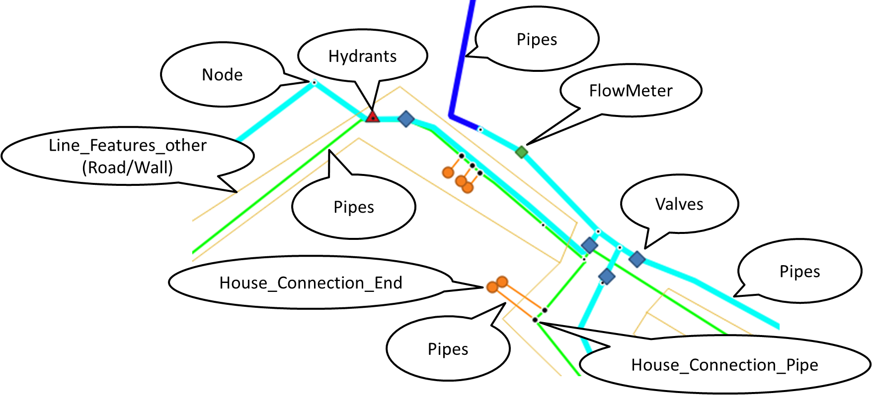

## Attribute Information

Attribute information is non-graphic information that accompanies graphic information. When the graphic information (shape) of a target feature in the real world is updated, such as when the position moves or the shape changes, the accompanying attribute information may be also updated. It is necessary to check the changed contents on site and update the attribute information as needed.

For detailed content and meaning of attribute information, refer to the external definition file.

## Base Map

For water distribution network data maintenance with GIS, it requires a basemap to locate target place and place correctly new features of the water facility such as pipe, valve, house connection, etc. on GIS map. Most accurate basemap is topographic map with high-precision survey measurement. However, it is very hard to keep the topographic map information updating all the time.

Today we can use a wide variety of web-basemaps through internet such as Google map, Google satellite map, Open street map, etc. Because web-basemap is automatically updated, Web-basemap allows users have instant access to the latest data easily. And it eliminates the process of updating map information by user organization. However, all users should always consider about the disadvantage of web-basemap also. Web base maps are not created based on high-precision surveying like the topographic maps mentioned above, so they have problems with location accuracy.

There is a problem with the accuracy of the position, but for GIS update work at KUKL, **OSM (Open Street Map)** shall be used in consideration of ease of use, update frequency, and amount of information especially roads and buildings information that helps to identify customer location “house connection end”.

## Positioning Accuracy

In order to maintain and manage GIS data, it is also necessary to understand the positional accuracy of the data. This is one type of GIS data quality management.

Information measured and collected on site is displayed on a GIS map. If there is no restriction on accuracy, the actual location of the site may differ from the location on the GIS map, or the positional relationships and distances between multiple managed facilities may differ from the local location. This may result in the information being displayed in a different state than the original, and the effectiveness of using GIS will be lost.

In order to maintain the quality of GIS data, it is important to build a standard of the positional accuracy and maintain constant positional accuracy. Considering KUKL's work, measurement methods, local conditions, etc., the following standards for the positional accuracy of various data handled in GIS data have been set.

When constructing new water pipes or service pipes, repairing or replacing them, the location of each target facility shall be measured and placed on a map in accordance with the following standards. The positioning error must be within the specified tolerances below; if it exceeds this, re-measurement on site will be required.

**Positional accuracy standard of the facility**

|  |  |  |  |
| --- | --- | --- | --- |
| **Target facility** | **Measuring position on site** | **Tolerance of Position error** | **Measurement method** |
| House connection end  (=Meter device) | At the property entrance | **within 5m** | GNSS in Tablet device  RTK-GNSS |
| House connection pipe  (=joint of Main pipe & Service pipe) | At the exact position | **within 0.5m** | RTK-GNSS |
| Valve/Flow meter  /Bulk meter/Hydrant | At the exact position | **within 0.5m** | RTK-GNSS |
| Pipe | At the exact position of both ends or vertex of the line | **within 0.5m** | RTK-GNSS |
| Service reservoir | At the representative position of the facility | **within 10m** | GNSS in Tablet device  RTK-GNSS |

# Updating GIS Data

## Overview of the Work

GIS data updating is an ongoing process to ensure that geographic information accurately represents the real world.

Updating GIS data in the water distribution is an important task that involves collecting, organizing, and maintaining geographical information related to water infrastructure and resources.

Updating water distribution GIS data is required to continuously processed, as the infrastructure is subject to wear and tear, expansion, and changes over time. Accurate and current GIS data is crucial for managing and ensuring the sustainable supply of clean water to communities while maintaining the integrity of water distribution systems.

## Target of the Updating Work

When on-site update work such as new installation, repair, or replacement was performed, the information subject to data update and the update method will change depending on the content of the work. When updating GIS data, it is necessary to understand what to update, how to update, target information and method.

Table: Specifications of Data Updates for Daily Update Works

|  |  |  |  |  |  |
| --- | --- | --- | --- | --- | --- |
| **Facility** | **Type of works** | **Data collection** | **Update Geometry data** | **Update Attribute information** | **Target Layer** |
| Pipe | Repair work | Yes | (Yes) | Yes | Pipe |
| Replacement | Yes | (Yes) | Yes |
| New Installation  / Extension | Yes | Yes | Yes |
| Others | Repair work | Yes | (Yes) | Yes | Valve/Flow meter  /Bulk meter/Hydrant |
| Replacement | Yes | (Yes) | Yes |
| New Installation | Yes | Yes | Yes |
| Meter  /Hole | Repair work | Yes | (Yes) | Yes | House connection end  House connection pipe  Pipe (Service pipe) |
| Replacement | Yes | (Yes) | Yes |
| New Installation | Yes | Yes | Yes |
| Location changed | Yes | Yes | Yes |
| Hole change | Yes | Yes | Yes |
| Customer information changed |  |  | Yes |
| Meter number changed |  |  | Yes |

## Workflow

Workflow of the updating work.

Updating work

Quality check

No

## Steps for the updating work

Steps for the work of Field data collection work using QField, Data integration, and Data update.

(Detailed instructions can be found in the operating manual.)

1. Prepare the layers of boundary for the target service area, buildings and roads.
2. Prepare existing layers of pipes and valves.
3. Save the layers to a new GPKG.
4. Create a project in QGIS and set layer properties.
5. Each supervisor should have a separate project for their service area.
6. Connect the master computer to the mobile device and copy the project and layers.
7. Collect field updates and location using QField.
8. Connect the mobile device to the master computer and copy all contents of collected field data.
9. The field data must be transfered to the master computer every two weeks.
10. Open the field data in QGIS and project it from WGS84 to WGS84-45zone.
11. Review the field data and return to the site to collect and record again if anything is missing.
12. Add only new field data with comparing the contents of records in attribute tables to avoid adding duplicate records to the master dataset.
13. If there is a change in the pipe route, modify the pipe layer.
14. Edit each layer based on the location recorded in the field to create connectivity with existing layers.

## Field Data Collection

Field work teams shall be dispatched to collect updated data on water distribution facility, such as pipe, house connection, valve, reservoirs and pumping stations. The team uses RTK-GNSS or Tablet mobile device with mobile GIS such as “Qfield” to accurately map these assets.

**[Sketch drawing]**

When any updating on site, Sketch drawing of the site is very important information and help you to locate on the map in the GIS updating work.

* Notice and draw any feature (Major natural and artificial features) that are important to include in the map.
* Draw by considering which side of the road the feature is positioned.
* Make a measurement and write the distance or coordinates on the map.
* [Case of Tape measurement]

Write these measured distances (approximations. “0.0” in meter unit).

* [Case of GNSS measurement]

Write the coordinates value (e.g. “27.123456, 85.123456” in degree unit) on the map.

* Consider the compass direction and add a north/compass arrow on the map.
* Write notes: (general location information, description of access routes from particular location, such as road name, intersection name, famous public facility, etc.)

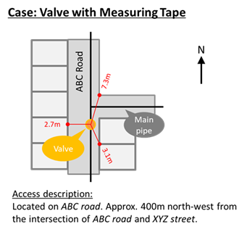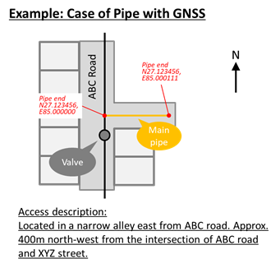

**[Tape measurement]**

Tape measurement is one of the methods to record the target location on site with Measuring tape and it helps to identify the target location on the map.

* Mark any feature (Reference point) you want to make measurements to around the target.
* Reference point shall be a location that is identifiable on your GIS base map.
* Reference points shall be selected at least 3 points.
* Measure the distance between target facility and reference points up to decimeter (“0.0”, one tenth of a meter).

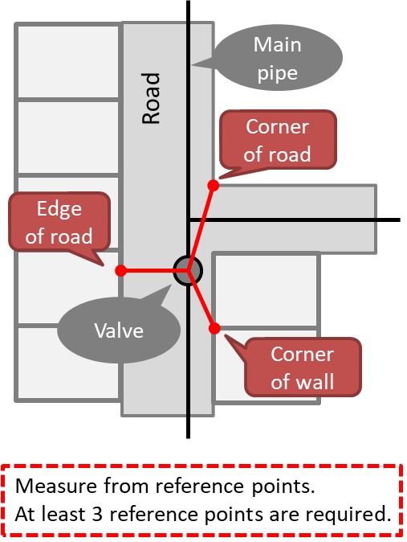

**[GNSS positioning by RTK-GNSS]**

GNSS positioning is one of the methods to record the target location on site by RTK-GNSS method with GNSS equipment and satellites system.

* 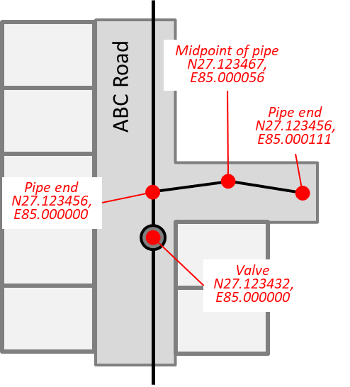Mark any feature you want to make measurements.
* Measurement position
* [Case of Point facility] such as “Valves” or “Meter”

Center of the target facility.

* [Case of Line facility] such as “Pipes”

Both ends and midpoints (vertex) of the target facility.

* Take GNSS coordinates using device.
* Record the measurement information

Point name/number

Coordinates value (e.g. “27.123456, 85.123456” in degree unit)

Description (name/position of the target facility)

**[Mobile device GIS “Qfield”]**

Android app of QGIS especially aimed for data collection at field work on mobile device. QField is a free and open-source mobile application that is optimized for handheld touch devices with supports viewing, editing at field work. QField helps users easily collect and update GIS data for fieldwork by combination with QGIS.

## Data Integration

All the collected data by the field data collection work is newly integrated into existing GIS database.

Utilize GIS software “QGIS” to edit, manipulate, and refine the data. Common GIS tools, such as digitizing, editing attributes, and geometry checks, are used to maintain data integrity.

Validate the newly added data for accuracy, consistency, and reliability. This involves quality control checks, attribute validation, and spatial accuracy assessment.

## Data Update

Update attribute information based on any changes or additions in the real world, such as pipe material, size, installation date, and maintenance history, to reflect the current state of the assets.

Update spatial data to reflect changes in the physical environment. This could involve adding new features, modifying existing ones, or removing obsolete features.

* Add new points and lines based on the field data, edit to connect with existing water pipe and service pipe data.
* The following rules will be used to connect existing water pipe network data and field data.
* Each point of the field data is connected and joined with pipe line layer according to the actual connection status of the water distribution pipe network.
* Field data points and adjacent existing data points are connected and joined with pipe line layer in accordance with the actual connection status of the water distribution pipe network.
* Remove unnecessary (old information) points and lines from existing data.
* Add or update new attribute information for the items defined in each layer while checking related materials.

Connect New data points with lines

Connect “new data points” to “vertices of the existing data”.

If the difference in coordinate values between a point in the existing data and a point in the field data is **50 cm** or more, reconfirm the location of the target object on site and record the coordinates again.

New data points collected on site

Vertices of the existing data

Remove unnecessary (old) part in the existing data.

**[General data creation rule for Points]**

* The position of the point facility (FlowMeter/ House_Connection_End/ House_Connection_Pipe/ Valves/ Hydrants/ Service_Reservoir) shall be placed at the “center position” or “representative position” of the target facility.
* The position of the point facility shall match the measured position (coordinates value of the measurement result) by GNSS or tape measurement on site.
* When the measured position is clearly incorrect (exceeding the specified tolerance for each facilities) due to an error of measurement, the measured position shall be corrected by re-measurement on site or adjustment manually on the map.
* Do not draw point data using curves (circles with lines).

**[General data creation rule for Lines]**

* The center line of the line facility (pipes) shall be placed at the “center line” or “representative line” of the target facility.
* The both end position of the line facility or vertex position shall match the measured position (coordinates value) by GNSS or tape measurement on site.
* Enter a line that is parallel to the road line and follows the road shape as much as possible.
* When the measured position is clearly incorrect (exceeding the specified tolerance for each facility), the measured position shall be corrected by re-measurement on site or adjustment manually on the map.
* When a curved line shape, use polygonal line with vertex. Do not use curves.
* Divide the lines when the attribute information of the line is different.
* The endpoints (=Joint position) of adjacent 2 lines should have same coordinate values. (connectivity)

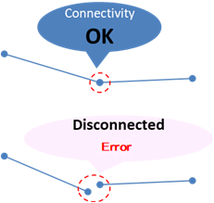　　　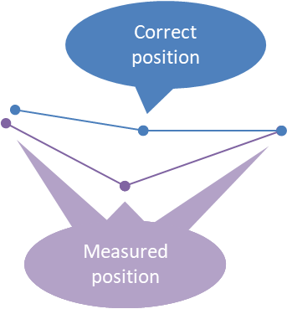

**[Data creation rule for *“House_Connection_end”*]**

* The point must be placed at the property entrance.
* Connected to the end of the “Service pipe”.
* Position error tolerance shall be 5m.

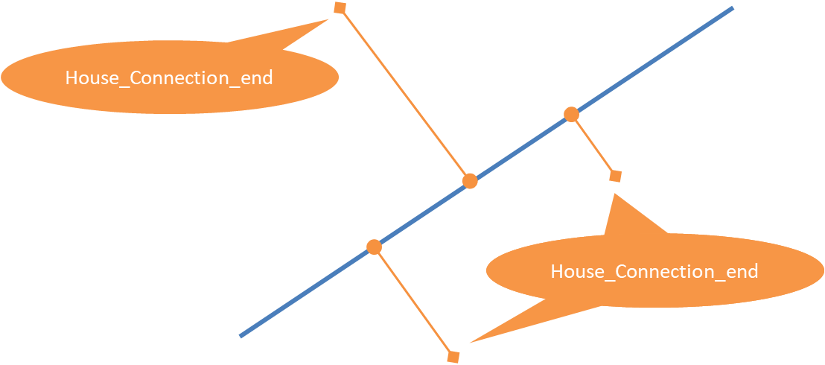

**[Data creation rule for *“House_Connection_pipe”*]**

* The point must be placed at the joint position of “Service pipe” and “Main pipe”.
* Position error tolerance shall be 0.5m.

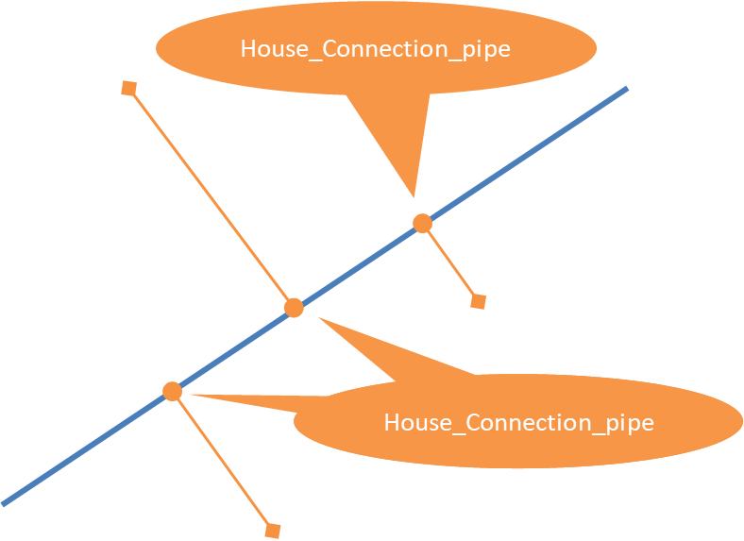

**[Data creation rule for *“Valve/Flow Meter/Hydrant”*]**

* The point facility (Valve/Flow Meter/Hydrant) must be placed at the end or on the pipe line (For connectivity).
* The position needs to be adjusted, if there is a gap (Allows up to 1m) between the point facility and pipe.
* If the gap is over 1m, re-measurement on site is required.
* Position error tolerance shall be 0.5m.

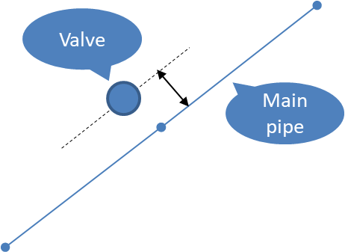

**[Data creation rule for *“Service_Reservoir”*]**

* The point must be placed at the representative position of the facility, such as, center of the facility, center of the facility property, center of main building in the facility property.
* Position error tolerance shall be 10m.

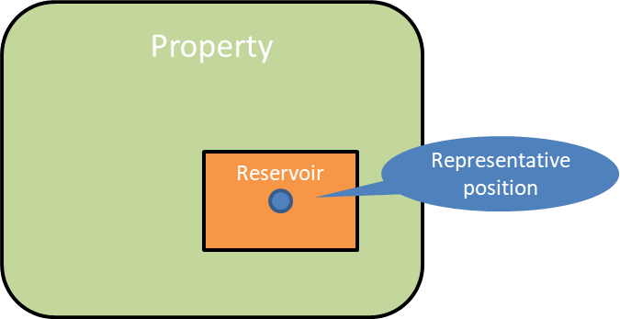

**[Data creation rule for *“Main pipe”*]**

* The line must be drawn by considering which side of the road the pipe is laid on.
* Positional adjustment is required if there is a gap between point facility and Main pipe (Allows up to 1m).
* Position error tolerance shall be 0.5m.

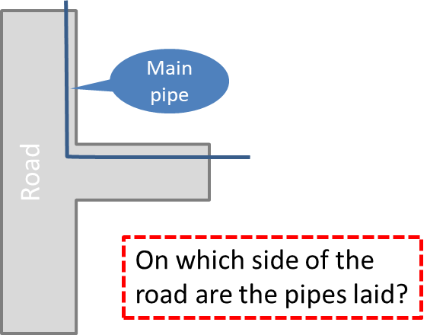 

**[Data creation rule for *“Service pipe”*]**

* The line must be drawn along the road to the property by considering and which side of the road the pipe is laid on.
* Both ends of the line must be covered & connected by “House_Connection_end” and “House_Connection_pipe” positioned on “Main pipe”.
* Position error tolerance shall be 0.5m.

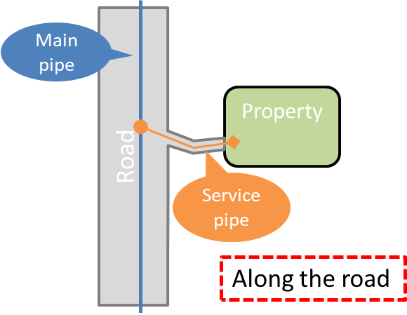 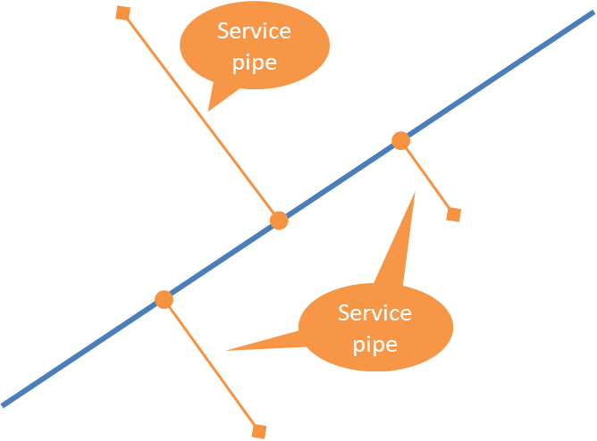

# Quality Check

## General

Quality assurance of water distribution GIS data is the process of ensuring the accuracy, completeness, consistency, and currency of geospatial data about water systems. GIS data quality checks are critical to the safe, efficient, and effective operation of water systems.

Quality testing of the GIS data validates data about water infrastructure, such as water pipes, valves, and pumps, to assess the accuracy, completeness, consistency, currency, and usefulness of GIS data. Before GIS data is used in decision-making or applications, it is critical to ensure the data is accurate and reliable.

The quality inspection process for GIS data includes the following steps:

1. Data review: Data controllers are required to review and analyze data to ensure its accuracy, completeness, consistency and currency.

2. Correction of data: If errors or deficiencies in the data are found during quality control procedures, the data controller is required to correct or update the data.

3. Data Validation: Data Controllers are required to review the data again to ensure that any corrections or updates to the data have been made accurately.

4. Approval of data: Data controllers must approve data to ensure that it meets quality standards.

## Type of the Quality check

Quality requirements for GIS data

1. Completeness: Data must be complete and without omissions or errors.

2. Logical Consistency: Data should be created and maintained in a consistent manner.

3. Accuracy (Positional & Thematic): Data must be accurate and obtained from reliable sources.

4. Freshness: Data should be kept up-to-date.

|  |  |  |  |
| --- | --- | --- | --- |
| **Quality Factor** | **No.** | **Quality Requirements** | **Error Description** |
| Completeness | C01 | Duplicate asset-id value does not exist in the data. | There are duplicate asset-id value in the data. |
| C02 | There is no excess or missing data compared to the field situation. | Facility data exists that does not exist in the field.  Facility that exists in the field are not entered in the data. |
| Logical Consistency | L01 | The Geopackage file is named correctly. | There is a file whose Geopackage file name does not conform to the rules. |
| L02 | The following data is created with point geometry.  House connection end/House connection pipe/Valve/Flow meter/Bulk meter/Hydrant | Data for House connection end/House connection pipe/Valve/Flow meter/Bulk meter/Hydrant are created with the geometry of other than point. |
| L03 | The following data is created with line geometry.  Pipe | Data for Pipe is created with the geometry of other than line. |
| L04 | All code values entered are the values defined in the　codelist. | A value is entered in the attribute table that does not match the code value defined in the codelist. |
| L05 | All GIS data are defined in the geospatial reference system CRS “EPSG:32645 – WGS 84 / UTM zone 45N”. | A CRS other than “EPSG:32645 – WGS 84 / UTM zone 45N” is set. |
| L06 | The data are two dimensional.  The unit of length is Meter. | The data is set to 3D.  A length unit other than Meter is set. |
| L07 | There are no duplicate vertices with the same coordinate value on a line.  A line consists of two or more vertices. | A line has vertices with the same coordinates.  There are vertices where the distance between consecutive vertices of the line is less than the proximity threshold (0.01m).  The line consists of less than 2 points. |
| L08 | Line must not have self-intersection. | Line has self-intersection. |
| L09 | There are no duplicate points with the same coordinate value in the data. | There are duplicate points with the same coordinate value where multiple points overlapped. |
| L10 | All lines are connected by lines/point | There is a line that is not connected to any lines or points. |
| L11 | All points are connected by lines | There is a point that is not connected to any line. |
| Positional Accuracy | P01 | Positioning Accuracy: within 5m  Feature: House connection end　(=Meter device)  Place: At the property entrance | If the distance is more than 5m from the actual site location, re-measure on site. |
| P02 | Positioning Accuracy: within 0.5m  Feature: House connection pipe　(=joint of Main pipe & Service pipe)  Place: At the exact position | If the distance is more than 0.5m from the actual site location, re-measure on site. |
| P03 | Positioning Accuracy: within 0.5m  Feature: Valve/Flow meter/Bulk meter/Hydrant  Place: At the exact position | If the distance is more than 0.5m from the actual site location, re-measure on site. |
| P04 | Positioning Accuracy: within 0.5m  Feature: Pipe  Place: At the exact position of both ends or vertex of the line | If the distance is more than 0.5m from the actual site location, re-measure on site. |
| P05 | Positioning Accuracy: within 10m  Feature: Service reservoir  Place: At the representative position of the facility | If the distance is more than 10m from the actual site location, re-measure on site. |
| Thematic Accuracy | T1 | Correct upstream/downstream pipe ID are entered. | The upstream/downstream pipe ID entered in the pipe attributes do not match the pipe ID of the pipes connected on the upstream/downstream sides. |
| T2 | Correct pipe ID are entered.  House connection end | The pipe ID entered in the House connection end attribute does not match the pipe ID of the Service pipe connected to House connection end. |
| T3 | Correct pipe ID are entered.  House connection pipe | The pipe ID entered in the House connection pipe attribute does not match the pipe ID of the Service pipe connected to the House connection pipe. |
| T4 | A House connection end and a House connection pipe point are connected to the ends of the Service pipe line.  The House connection end is on the property side and the House connection pipe is on the water pipe side. | Both ends of the Service pipe line are not connected to both the House connection end and House connection pipe points.  House connection end and House connection pipe are not connected to the line at the correct position. |
| T5 | A House connection pipe connects to the Main pipe. | House connection pipe is not connecting to Main pipe. |
| T6 | Valve/Flow meter/Bulk meter/Hydrant connects to Main pipe | Valve/Flow meter/Bulk meter/Hydrant not connected to Main pipe. |

## Workflow

Workflow of the quality check.

Quality check

Updating work

No

## Steps for the Quality check

Steps for the quality check, Data check, Data correction, Quality Inspection.

(Detailed instructions can be found in the operating manual.)

1. Prepare and load the updated layers on QGIS.
2. Conduct geometry check by using GIS feature, and attribute information check by comparing with source information.
3. Check and correct each error found by the checks.
4. Conduct geometry check and attribute information check again.
5. Repeat the above steps 3 and 4, until all the error are corrected.
6. Submit the updated data to Head office.
7. Inspector at Head office check all the updated data from each branch office.
8. Inspector shall check objectively and from a comprehensive perspective to ensure consistency across all branches.
9. If an error is found, write a comment at the error part of the GIS data and save it.
10. Inspector sends the feedback of the inspection with the comment to each branch office.
11. At the branch office, correct the data based on the feedback from the Inspector.
12. Repeat the above steps from 6 to 11, until all the error are corrected.
13. If no errors are finally found, the Inspector cleans up all branch data and saves the data to an archive folder on the GIS server.

## Data Check/ Data Correction/ Quality Inspection

Conduct quality control processes to identify and rectify errors or inconsistencies in the updated data. This may involve validation checks, data cleaning, and error correction.

**[Geometry errors]**

In addition to the items indicated in the quality requirements, the geometry errors listed below must be resolved using the geometry check function of GIS.

|  |  |  |  |
| --- | --- | --- | --- |
| No | Rule for Lines/Points | Error | |
| 1 | Must Not have Overshoots | Line | **Error** |
| 2 | Must Not have Undershoots | Line | **Error** |
| 3 | Must Not have Gap (Disconnected) | Line  Point | **Error** |
| 4 | Must Not have Dangles | Line | **Error** |
| 5 | Must Not Twisted or Self - Intersect | Line | **Error** |
| 6 | Must Not Cutback | Line | **Error** |
| 7 | Must Not Loop | Line | **Error** |

**[Feedback comment of Inspection]**

During data quality inspection by the inspector, comments on the cause of the error and correction instructions are recorded at the error location as feedback. As shown in the table below, it is important to unify the contents of the comments to some extent so that instructions from the inspector can be conveyed to the person in charge of data correction without misunderstanding.

|  |  |  |  |  |  |  |
| --- | --- | --- | --- | --- | --- | --- |
| **Comment** | | **Error** | **Example comment for each target** | | | |
| **Existence** | **Figure** | **Attribute** | **Geometry** |
| Add | Add | Missing feature/information | Add Valve  Add Pipe line | N/A | Add value of length  Add category code | N/A |
| Del | Delete | Unnecessary feature/information | Del Pipe line | N/A | Del name  Del value | N/A |
| CG | Change  Modification | Mismatching feature/information | N/A | CG extend pipe line  CG add vertex of pipe line along with road  CG connect to end of adjacent pipe line  CG split pipe line | CG category code  CG ID number  CG value  CG name | N/A |
| MV | Move | Wrong Position | N/A | N/A | N/A | MV to next road |
| CK | Check again | Error other than above errors | CK What is this? | CK figure of pipe line | CK all vale of the pipe id=0000 | CK geometry |

# Information Security

## Necessity of Information Security Actions

The Internet connected with the world has already become indispensable to our living, and the internet technology continues to progress and change rapidly every day.

In the past, information security actions meant to protect physical computers and networks of organizations, such as anti-virus, information encryption, data backup, firewall installation, network monitoring and control, and so on.

However, with the spread of the Internet worldwide and the number of users rapidly increasing, problems such as virus infection, intrusion, fraud, privacy invasion, information leakage, etc. that misuses Internet technology have become frequent, In addition to conventional physical countermeasures, security actions for “information” and “person” who use that information became necessary.

Therefore, **it is important that each user has appropriate knowledge and necessary security actions** so that other users and society can do secure utilization of Internet and information.

## Actions for Organizations and Companies

Organization or Company has many important information such as confidential information on management, sales, technology and personal information of customers and employees. In addition, the service stops due to system malfunctions may have a significant social impact.

**For organizations and companies, taking appropriate information security actions is already a social obligation.** In addition, it is recognized worldwide that information security actions is important management issues, and the certification standard (ISO/IEC 27001) of the information security management system is standardized as an international standard.

**Each user who belongs to organizations and companies must have appropriate knowledge of information security.** Especially in a connected network, just neglecting the virus countermeasure of only one computer, the virus will spread throughout the network and it will be a major damage.

In order to avoid suffering from such damage, various information security actions are required for organizations and companies, such as information security policy formulation, equipment countermeasure, user authentication, security training, countermeasures against illegal intrusion and hacking, and so on.

## What is threat of Information Security?

Taking countermeasure to protect “Information Assets” from various threats. It is important to reduce risk as much as possible by taking “Information Security Actions”.

|  |  |
| --- | --- |
| **Storage medium** | **Individual threat** |
| Document | Loss or Theft of Confidential information at office |
| Loss or Theft of Confidential information outside |
| Illegal-carryout of information aimed at “Information exploitation” |
| Loss of business information |
| Digital storage media | Loss or Theft of Confidential information at office |
| Loss or Theft of Confidential information outside |
| Illegal-carryout of information aimed at “Information exploitation” |
| Loss of business information |
| Office PC | Cyber-terrorism aimed at “Information exploitation” |
| Internal fraud aimed at “Information exploitation” |
| Loss of business information due to failure of PC |
| Failure of PC due to Malware infected |
| Cyber-terrorism aimed at “illegal money transfer” |
| Mobile device | Cyber-terrorism aimed at “Information exploitation” |
| Illegal software installation aimed at “Information exploitation” |
| Loss or Theft of Confidential information |
| Server | Cyber-terrorism aimed at “Information exploitation” |
| Internal fraud aimed at “Information exploitation” |
| Loss of business information due to failure of Server |
| Account hijacking due to Easy-to-Crack password |
| Loss of business information due to No data backup |

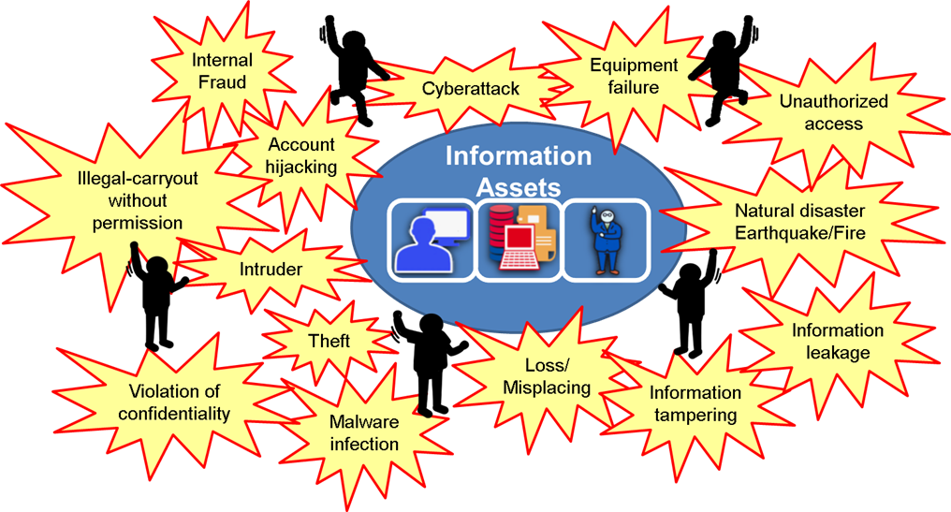

## Impact on organization caused by Information security incidents

Learn the damages and impact on organization caused by negligent duties of information security, and recognize the importance of the Information security actions.

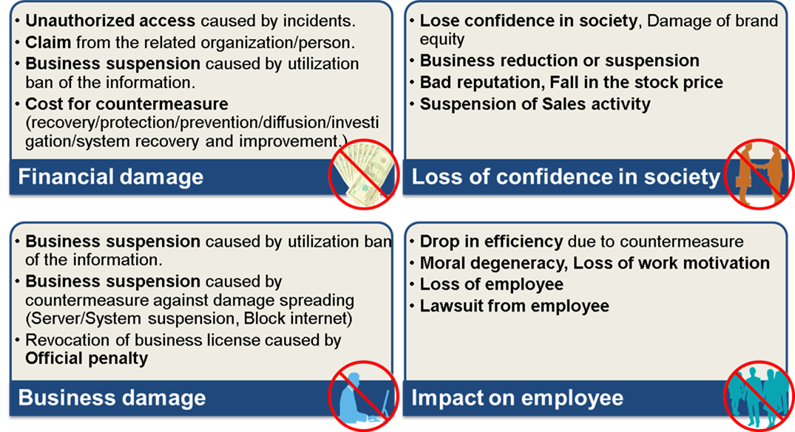

## Information Assets

“Information Assets” together with “Human resource”, “Goods/Services” and “Money/Capital” are important “Managerial Resources” that is the basis for forming an organization/Company.

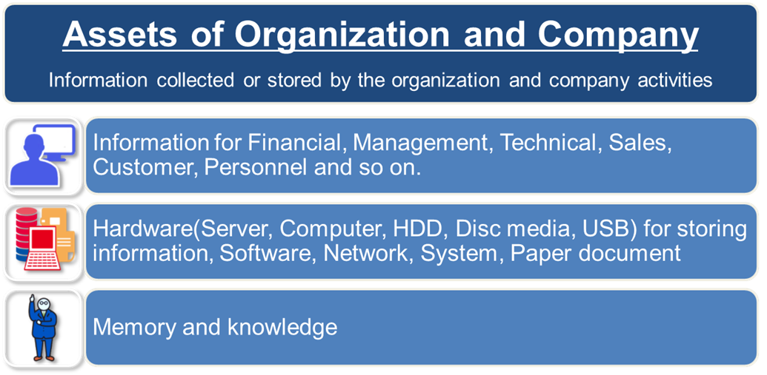

## Information Security Actions for Geospatial Information and GIS

For the operation of Geospatial information and GIS, what kind of security actions are needed.

Not only Satellite/Aerial imagery, Topographic/Cadastral maps, and any Thematic maps, but also all kind of information such as Name, Category, Numeric value, Personal information, can be Geospatial information by combining location information.

Geospatial information can be categorized as one of “Personally identifiable information” in terms of privacy, because the location of individuals can be identified using location information.

Since Geospatial information and GIS are also one of the “Information Assets” of the organization, they must be secured at the same level of security as other information according to the same information security policy.

* When Geospatial information is published by Web-GIS, separated web-server from organization network must be used to protect and avoid unauthorized access via internet.
* When use Geospatial information at the organization, manage with categorizing the information, such as, shareable information, authorized information for each department.

## Priority of Information Security Actions

It is not feasible to perform all security actions simultaneously against all kind of threats. Therefore, it is important to take countermeasures by determining the priority of security actions from various factors such as state of the organization, importance of the information assets that is exposed to the threat.

< Factor of priority >

* Importance of the information
* Frequency of Risk occurrence
* Impact of loss (influence on stakeholders, etc.)
* Available countermeasure technology
* Rules, Education / Training, Habitual behavior
* Feasibility of countermeasure
* Investment level to operate target information
* Cost for countermeasure
* Laws or contractual responsibilities
* How tolerable the identified residual risk is

## Actions by Organization

Allocate balanced countermeasure to all four groups of Information security actions.

