**GIS Work**

**[Appendix]**

**RTK-GNSS Standard Operating Manual**

**March, 2023**

**JICA Project Team**

Table of Contents

Chapter1 GNSS 1

1-1 Introduction 1

1-2 General 2

1-3 Ambiguity 2

1-4 Point positioning (Standalone) 3

1-5 Differential positioning (Code DGNSS) 4

1-6 Differential positioning (Carrier phase DGNSS) 4

1-7 Static method 5

1-8 Kinematic method 6

1-9 RTK (Real-time Kinematic) method 7

Chapter2 Position Accuracy 8

2-1 Accuracy 8

2-2 Consideration of Horizontal position 8

2-3 Consideration of Vertical position 9

Chapter3 RTK Measurement Procedure 12

3-1 Planning & Reconnaissance 12

3-2 Standard Measurement Procedure 13

# GNSS

## Introduction

You may create your own thematic map by collecting position information on site in your daily work with GIS. Such as facilities, building location, investigation point, boundary points of the property, location of new constructed structure. In the past, it was necessary to make difficult measurements using special and expensive surveying instruments by land surveyor in order to obtain coordinate values on site.

However, with the recent spread of space technology and the Internet, anyone can easily obtain coordinate values using satellite systems, “GNSS”, on your smartphone also.

**What is GNSS?**

GNSS (Global Navigation Satellite System) is a general term for satellite positioning systems such as “**GPS**” of the United States, “**GLONASS**” of Russia, and “**Galileo**” of the European Union, “**BeiDou**” of China, “**NAVIC**” of India, and “**QZSS**” of Japan. GNSS enables to determine your position on the ground by knowing the distances from four or more satellites at the same time using satellites that orbit tens of thousands of kilometers above the sky. The distance from the satellite is calculated from the time required for the radio waves transmitted from the satellite to reach the receiver. Radio waves transmitted from satellites include satellite orbit information and accurate time information of atomic clocks.

## General

The position of a station (GNSS receiver) is calculated from distance measurement between satellites and GNSS receiver. The coordinates of the position is based on the WGS 84 geocentric ellipsoid model. The distance is determined by measuring how long a radio signal takes to reach a receiver from that satellite.

Mobile phone GPS/GNSS

Handheld GPS

Differential positioning

Static positioning

Carrier phase DGNSS

Point positioning

Code DGNSS

Kinematic positioning

RTK

## Ambiguity

For the distance determination between satellites and GNSS receiver, the correct number of integer wavelengths must be found.

Actually, a lot of possible solutions (Ambiguity) exist on the line between satellites and GNSS receiver. In the “Carrier phase DGNSS”, briefly described, Ambiguity exists around 20 cm interval on the line because of its wavelength.

Once the ambiguities are resolved, then the distance determination problem can be solved.

Number of integer Wavelengths is unknown.

Less than 1 Wavelengths is calculated from phase.

## Point positioning (Standalone)

The position of a receiver is calculated by point positioning method of GNSS surveying. The position is determined based on distances from 3 satellites to a receiver.

The measurement from 3 satellites is required to calculate 3 parameters of the position. Besides, receiver clock errors can be canceled by a measurement to a fourth satellite due to the satellite has accurate atomic clock.

Therefore, theoretically at least 4 satellites are required to determine the position of a receiver.

* Precise Point Positioning (PPP)

PPP is one of the methods of GNSS Point positioning with single GNSS receiver.

It is an independent precise positioning method, using precise orbit/clock information of reference satellites and code and phase measurements from a receiver, without reference stations.

The orbit/clock information of reference satellites are computed by a processing centre with measurements from a network of GNSS reference stations distributed worldwide.

PPP is different from Real Time Kinematics (RTK) positioning in the sense that it does not require the measurements from reference stations, and that PPP provides an absolute positioning instead of the relative location to the reference station as RTK.

## Differential positioning (Code DGNSS)

Code DGNSS is one of the methods of GNSS differential positioning.

The principle of Code DGNSS is same with Point positioning. This method provides relative position by Point positioning at reference station and one or more new stations. The errors are differentiated using reference station.

## Differential positioning (Carrier phase DGNSS)

Carrier phase Differential is another method of GNSS differential positioning. Carrier phase Differential provides a relative baseline between 2 receivers. The baseline is determined based on difference of distances from a satellite to 2 receivers.

Baseline

Difference of distance from a satellite

**Equidistant curve**

Reference Station

The measurement from 3 satellites is required to calculate 3 parameters of the baseline vector. Besides, one more measurement from a satellite is required to remove clock error due to the difference of accuracy between the atomic clocks on satellites and the clock on receiver.

Therefore, theoretically at least 4 satellites are required to determine a baseline between 2 receivers.

This method provides relative coordinates of the receiver with a baseline to the reference station.

## Static method

Static method is one of the methods of GNSS Carrier phase DGNSS. Besides, it is the most accurate and used for any order survey.

In Static method, the receivers that are set up at stations receive signals from the same 4 or more satellites simultaneously during a same time measurement (a session), several-hours. It enables the error of the weather and the ionosphere to be averaged.

* Concerning to the Ambiguity problem

During the measurement, almost solutions change its position simultaneously due to the satellites geometry changes on orbit as time passes. But a solution that minimizes the residual error must exist in all candidate solutions. It should be the correct solution. (Fix the Ambiguity)

Static method finds an optimal solution that minimizes the residual error in all candidate solutions, by the satellites geometry changes.

***Optimal solution***

Possible solutions

Satellite moved

Possible solutions

by the satellites geometry changes

## Kinematic method

Kinematic method is another methods of GNSS Carrier phase DGNSS.

Kinematic method can determine the position of the rover receiver continuously, only while several-minutes or several-seconds, with the measurement at a reference station.

The receiver that is set up at a reference station (Base) is fixed during the measurement. Another or more receivers move continuously from point to point for measurement.

In this method, because of all the middle points are determined individually, the accuracy of each point does not affect to the overall accuracy. But, conversely, it means that it is difficult to find the individual error. Therefore, multiple measurements are required to check the accuracy of each point.

Kinematic method can resolve the Ambiguity by the measurement at a reference station (Base). It enables to shorten the measurement time.

Theoretically, the measurement time to determine the position by GNSS surveying is several seconds. But, Static method requires several-hours measurement in order to resolve Ambiguity by another method (using the satellites geometry changes).

The difference of the Static method and Kinematic method is the method how to resolve the Ambiguity.

## RTK (Real-time Kinematic) method

“**RTK**” is one of the kinematic methods. When the position of a rover receiver is determined in real time by transmitting correction information using radio or internet communication, it is called real-time kinematic (RTK).



Correction info

**Base Station**

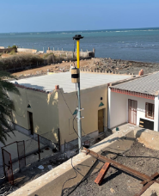

**Rover Station**



# Position Accuracy

## Accuracy

Accuracy refers to the radius of the circle by the set of measurement points plotted around the most probable position. The smaller the radius, the higher the accuracy of the measurement.

Note that it is not accuracy of the true position, accuracy refers the reliability of the measurement in the GNSS positioning. And, the most probable position may not same as the true position.

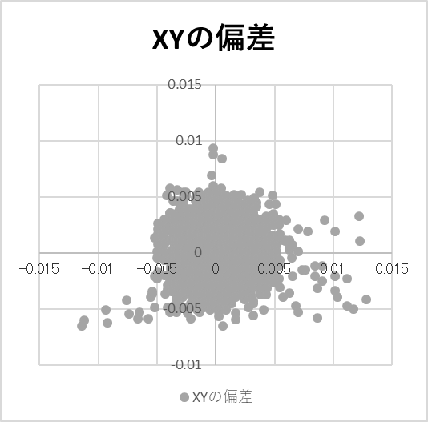

The most probable position

Accuracy circle

## Consideration of Horizontal position

It is generally said that the RTK-GNSS system enables cm-level horizontal position accuracy under good conditions within 10 km distance from the Base station.

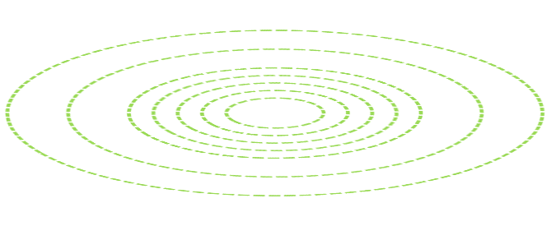

1

5

3

7

10km

**Rover**

**Base station**

* Understand the Base map accuracy

The following list shows the position accuracy of digital topographic map data (base map) for each "map information level" (Japanese standard). This means that all spatial information has any position error. Therefore, users need to understand and adopt it depending on the required map accuracy. Please note that even if the measurement is made accurately in the field, the position accuracy of the measurement may not match the accuracy of the base map.

|  |  |  |  |  |
| --- | --- | --- | --- | --- |
| Map Information Level | Map Scale | Standards deviation | | |
| Horizontal position | Vertical position | Contour line |
| 1,000 | 1/1,000 | Less than 0.7m | Less than 0.33m | Less than 0.5m |
| 2,000 | 1/2,000 | Less than 1.4m | Less than 0.53m | Less than 0.8m |
| 5,000 | 1/5,000 | Less than 3.5m | Less than 1.66m | Less than 2.5m |
| 10,000 | 1/10,000 | Less than 7.0m | Less than 3.33m | Less than 5.0m |

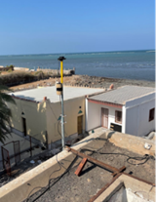　　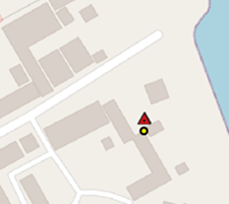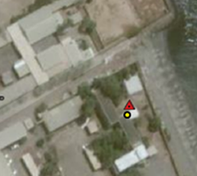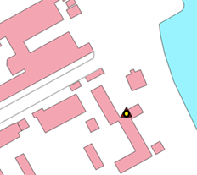

## Consideration of Vertical position

When use the GNSS measurement, it is required to understand the 3 types of height, Ellipsoidal height, Geoid height, Elevation. The result of the height by GNSS measurement shall be Ellipsoidal height. In order to get the elevation of the measurement point, there are 2 major methods.

1. By “Levelling measurement” based on the national reference point of elevation.
2. By “Calculating” with Geoid height (get from geoid models) at the measured horizontal position.

However, Elevation calculated from the GNSS measurement and the Geoid height based on the geoid models are not accurate enough to be used as a substitute for elevation by levelling measurement.

Note that the “Levelling measurement” is more accurate than “GNSS & Geoid height”.

* Ellipsoidal height

The GNSS receiver can measure the height from the reference ellipsoid (“Ellipsoidal height”), which is the ideal shape model of the earth. Ellipsoidal height is the distance between a point on the ellipsoid plane and a point on the surface of the earth, measured along a line perpendicular to the ellipsoid. At some point, if the reference ellipsoid is below the surface of the earth, the ellipsoidal height is positive value. When above the surface of the earth, the ellipsoidal height is negative value.

* Geoid height

Geoids indicate that the sea level around the planet is rising or falling due to geographic variation in gravity in the absence of tidal currents. It is called the elevation at Mean Sea Level (MSL). Geoid height is the distance measured from the ellipsoid to the geoidal plane along a line perpendicular to the reference ellipsoid.

In some countries, precise gravity surveys are carried out to create a country-specific geoid model (Earth Gravitational Model). However, if such a precise geoid model has not been measured, you can use the global geoid model provided by the National Geospatial-Intelligence Agency (NGA) to obtain the geoid height at the point measured by GNSS. There are **EGM2008** and so on.

However, it must be understood that the elevation values calculated using the geoid heights obtained from the geoid model are inferior in accuracy to the elevation values obtained by leveling measurement. Therefore, when detailed design considering the height from the sea surface is required, such as roads and buildings, it is desirable to determine the horizontal position by GNSS and to carry out leveling for the elevation separately.

* Altitude above sea level (Elevation/Orthometric height)

Altitude above sea level (commonly referred to as "Elevation") is measured height along a plumb line from a geoid to a point on the surface of the earth. You can say that elevation is the height from the Mean Sea Level (MSL).

Ellipsoidal Ht

Elevation

Geoid

Earth surface

Ellipsoid

Geoid Ht

Ellipsoidal Ht

Elevation

Geoid

Earth surface

Ellipsoid

Geoid Ht

**Ellipsoidal Ht**

**Elevation**

**Geoid Ht**

**-**

**=**

Case 1

Ellipsoidal Ht = 25m

Geoid Ht = 15m

Elevation = 10m

**Example1**

Case 2

Ellipsoidal Ht = -5m

Geoid Ht = -15m

Elevation = 10m

**Example2**

# RTK Measurement Procedure

## Planning & Reconnaissance

Planning and Reconnaissance is the most important part of a GNSS survey. Proper planning and reconnaissance is essential for efficient and effective measurement.

* Satellite Visibility
* Stable internet connection
* Measurement schedule
* Satellite Visibility Requirements

The observing station must have a clear view of the sky for at least 15 degrees or greater above the horizon during the measurement when observable satellites are in the sky.

Obstructions and multipath potential

|  |  |
| --- | --- |
| **Error type** | **Obstructions** |
| Signal delay errors | Metal, buildings, or trees when passing through leaves, glass, plastic, etc. |
| Disturb signal receiving | Locations near strong radio transmissions, radio/TV antenna, etc. |
| Multipath errors | Locations near large flat surfaces such as buildings, large signs, fences, etc. |

15**° or greater**

1.5m or higher

## Standard Measurement Procedure

Standard procedures of GNSS measurement, especially RTK are as follows in principal.

* Preparation

In particular, the receiver battery and smartphone must be charged the day before measurement work. Furthermore, SIM card setting and internet connection must be prepared in advance.

* Weather Conditions

Generally, Normal weather does not affect to GNSS measurement with the following exceptions:

* During raining heavily, lightning, electrical storms
* Snow or ice piling up on top of the receiver might block the signals
* Cold weather will reduce the capacity of the battery
* Equipment Checklist

Check equipment and materials for measurement work before leaving your office.

Checklist

|  |  |
| --- | --- |
|  | Receiver set (Receiver, Memory card, Antenna) |
|  | Cables |
|  | Clamps, accessories |
|  | Battery and Battery charger |
|  | Pole |
|  | Smartphone |
|  | Measuring tape |
|  | Document & maps of the measurement target |
|  | Pen and notebook |

* Operating procedures

The basic operating procedures of RTK-GNSS measurement are as follows

* **Receiver setup**

Mount the receiver on the pole, and attach the Antenna to the top of the pole with accessories (cables & clamps). GNSS signals can be affected by the objects around the Antenna, such as parking vehicles, sign board, close to the communication antenna can affect or block the signals. Therefore, higher set up (higher than 1.5m) is recommended.

* **Measuring the Antenna height**

Always measure the Antenna height to centimetres (in meter unit) and record it on your notebook. Measure the Antenna height twice, before and after each measurement so that you can find the Antenna height has changed during measurement.

* **Receiver start up**

Turn on the receiver about 5 minutes before the measurement to initialize the receiver and wait for the receiving satellite signals to stabilize.

* **Internet & Bluetooth connection**

Check the smartphone internet connection is available and stable. Turn on the Bluetooth and pair with the receiver.

* **RTK Application setup**

Confirm the settings on the smartphone, then Connect with the receiver. If the connection between smartphone and the receiver is successful, the coordinates value and Fix type (“DGPS”) of your current location is displayed.

* **NTRIP connection**

NTRIP connection is needed as well as the settings on the smartphone to receive calculated coordinate value. If the NTRIP connection is successful, the Fix type changes from “DGPS” to “Float”. Then wait until the status finally changes to “Fix”.

"Float" indicates that the positioning accuracy still has ambiguity.

"Fix" indicates the positioning accuracy is almost determined. Ready to survey.

* **Place the rover pole**

Place the pole at the exact position of the measurement point.

* **Logging & Monitoring**

Even if the Fix type is already “Fix”, monitor the accuracy (horizontal / vertical) until the accuracy finally stabilizes (When the value becomes stable). If the accuracy still shows greater than 0.3m, try to improve the condition such as, Higher pole with extension, Internet condition, Wait until the number of captured satellites increases, etc.

* **Recording**

When you get “Fix” and the accuracy is stable, you can record the position with entering the Point name. During the recording, keep the pole as stable as possible and level the bubble.

* **Antenna height difference during work**

If the difference of the Antenna height between before and after the measurement exceeds 1cm, the measurement must be made again.

* **Move to next point**

Do not leave your belongings. When moving with the receiver and the pole, keep holding the pole upright in front of you while you walk so that the receiver does not hit with the surrounding objects or drop from the pole.

* **End of the fieldwork**

When the work is completed, all the equipment shall be packed in the box or bag to avoid any belongings being left on site.

* **Transfer the Recording data**

The recorded data stored in the smartphone needs to be transferred by using e-mail to your e-mail address for post-processing (plot measured points on the map) with GIS.

Setup manual of “SW Maps” RTK system

|  |  |
| --- | --- |
|  | 1. Antenna 2. “SW Maps” Receiver device with memory card 3. Antenna cable 4. Spare Antenna cable 5. Clamp for “SW Maps” Receiver device 6. Clamp for Mobile device holder 7. Mobile device holder 8. Antenna attachment 9. Charger and USB cable for Receiver |

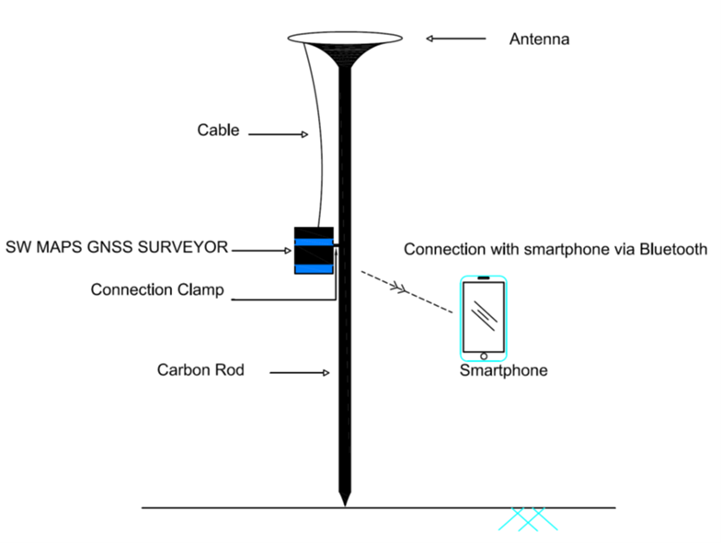



Record Button

RTK Indicator

Satellite Indicator

Bluetooth Indicator

Recording Indicator

Battery Level Indicator

|  |  |
| --- | --- |
|  | Extend the pole and set at 2.0m |
|  | Insert a stopper |
|  |  |
|  | Attach a clamp for “SW Maps” receiver device to the middle height of the pole.  A rubber washer has been provided for a better/tighter attachment. |
|  | Connect clamp and the Receiver device with screws |
|  | Tighten the screw |
|  | After attaching the receiver. |
|  | Attach the antenna to the top of the pole |
|  | Connect a cable to the Antenna.  The bigger connector of the cable on the antenna. |
|  | Connect the other end of the cable to the Receiver device.  The smaller connector of the cable on the receiver.  Precautions: Need to be careful not to get the cable stuck in the surrounding objects while carrying out survey works. |
|  | Attach the clamp and Mobile device holder.  This is more helpful when a single person needs to collect and record data. |
|  | Confirm the SD card is inserted |
|  | The figure on the bottom of the antenna shows the height to the centre of the antenna. (50.5mm=0.05m)  Set the antenna height by adding 0.05m to the set pole height.  If the pole height is set to 2.0m, the antenna height of the setting will be 2.05m. |

|  |  |
| --- | --- |
|  | Battery charging status  The light indicator shows the battery status.  Green: Battery status good.  Yellow (Shown here): Battery status low.  Red: Battery status very low.  *Once charged fully, this will last for 24 hours. This can also be charged with portable charger while working.  *Information mentioned by Mr. Prashant verbally in the video. |
|  |  |
|  | Receiving information from satellite.  After the connection to satellite is established, the indicator will start blinking. |
|  | Receiving information from satellite  Connecting Bluetooth status.  Bluetooth signal indicator:  Blinking: not proper connection yet.  Constant light: OK |
|  | RTK observation status  Receiving information from satellite  Connecting Bluetooth status  RTK signal indicator:  Blinking: not proper connection yet.  Constant light: OK  RTK will glow constant after internet connection is established. |

End of document